Gay Male Porno Comics: Genre, Conventions, and Challenges
By Dr. Sina Shamsavari

Gay male comics – and gay male pornographic comics in particular – have received little scholarly attention. However, as I have previously demonstrated (see Shamsavari 2017b) the history of gay male comics is rich, stretching from the early 20th Century to the present day. It can be considered in terms of a long “pre-Stonewall” period and following the Stonewall riots in 1969, in terms of a number of “waves” of activity. The “First Wave” stretches from 1969 till 1990, the Second can be indentified with the 1990s, and the Third can more or less be equated to the new Millennium. Two dominant genres have emerged within the field of gay male comics, crystallizing during the First Wave: the gay ghetto comic strip, with its emphasis on humour and representations of community (see Shamsavari 2017a), and the gay porno comic, which is the subject of this article. I have previously presented a rough definition of the gay porno comic in a broader discussion of gay male comics field (Shamsavari 2017b), but in the present article, I will discuss the generic tendencies of the gay porno comic in more depth.
This first part of this article will focus on the generic tendencies of gay porno comics produced in the pre-Stonewall and First Waves of American gay male comics production – what we might term “mainstream” gay male porno comics. I will discuss the character types, scenarios, and drawing styles commonly found in these gay porno comics, and with reference to John Mercer’s (2004) work on gay pornographic video, I will discuss a number of discourses that gay porno comics commonly draw upon. I argue that the mainstream gay porno genre represents gay sex and gay male bodies in an idealized way, constructing an ideal “type” of gay male identity and sexual habitus, valorising the values and ideals of a gay male culture in which idealized, youthful and athletic male bodies are highly prized, and sex with a variety of partners is celebrated and seen as central to gay male identity.
In the latter part of this article I will go on to discuss what I call the “alternative gay porno comics.” These comics by Second- and Third Wave gay male cartoonists (produced in the 1990s and the first decade of the 21st Century) respond to the conventions of the gay porno comics genre, taking up aspects of the porn genre’s conventions – explicit sex, idealized bodies, and the intention to arouse – but doing something different with the genre. I argue that in a number of important ways, the Second- and Third-Wave alternative gay porno comics subvert the conventions of the mainstream gay porno comics genre by placing explicit sexual scenarios into more complex emotional narratives.
Some of these stories are set in the contemporary, “real” world; others are set in fantastic, otherworldly realms or involve supernatural beings. Whether “realistic” or “fantastical,” these pornographic narratives open up a world of complex emotions, sexual identities and interrelationships. In emphasizing the emotional dimensions of sex, these alternative porno comics explore similar territory to the alternative gay ghetto comics I have previously discussed (Shamsavari 2017a), questioning and challenging more conventional notions of gay identity and community, as well as binaristic and normative notions of gender and sexuality. Moreover, I argue that these alternative gay comics can be seen as examples of what Muñoz (2005) calls “queer world-making”, a Utopian activity that responds to and attempts to correct the erasure of queer lives and sexual cultures in heteronormative societies.

A Brief History of Gay Male Comics

Gay male comics developed from the illicit graphic narratives circulating in North America and Europe in secret in the late 20th Century (Waugh 2002), and from the softcore erotic illustrations appearing in the physique magazines of the 1950s. One of the most famous of these magazines Bob Mizer’s Physique Pictorial (1951) included “physique art” – illustrations – alongside photographs, and in 1957, it published the work of the Finnish artist Touko Laaksonen under the pen-name “Tom of Finland.” Tom of Finland would go on to become arguably “the best-known . . . producer of gay erotica of the second half of the twentieth century” (Ramakers 2000: x), and extremely influential on gay pornographic illustration and comics.
Non-pornographic gay comic strips appeared in the United States in the 1960s. In 1964 the gay liberationist magazine Drum became the first gay publication to feature an ongoing gay comic strip, Harry Chess: That Man From A.U.N.T.I.E, written and drawn by Al Shapiro (Mills 1986: 9). During the 1960s, a number of United States Supreme Court rulings liberalized pornography laws, allowing for the commercialization of pornography (Ramakers 2000: 5), and after the Stonewall Riots, the 1970s saw the proliferation of openly gay, homoerotic magazines with full-frontal nudity and sex, such as Mandate, In Touch, Honcho, and Drummer. From the mid-to-late 1960s and into the 1980s, many of these magazines came to feature gay comic strips and cartoons. This period can be considered the “First Wave” proper of gay male comics production (Shamsavari 2017b).
The comics that appeared at this time included the type that I have described as “gay ghetto” comics (see Shamsavari 2017a), but this period also saw the gay porno genre beginning to thrive in the USA. In Touch published Klamik’s (“Sean”’s) erotic work, and Drummer became the new home to Shapiro’s Harry Chess and British artist Bill Ward’s erotic strip Drum (not to be confused with the earlier magazine Drum). At roughly the same time, comic books featuring the work of a single author began to be published, including Etienne’s Adventuretime, and Tom of Finland’s hardcore Kake comic books, published in Denmark and Sweden in 1967 (Ramakers 2000: 5).
An anthology comic book dedicated to non-pornographic comics by both gay men and lesbians was founded in 1979: the influential Gay Comix, edited by cartoonist Howard Cruse (Shamsavari 2017b). Gay Comix was joined in 1986 by another gay-themed comic-strip anthology, Meatmen, dedicated mainly to pornographic gay male comics. The earlier volumes of Meatmen mainly featured reprints of comics by artists like The Hun, Stephen, and others, but later volumes, published throughout the 2000s, featured more original work. Together, Gay Comix and Meatmen virtually defined the field of gay male comics in the late 1980s, and in many ways served as exemplary collections of the gay ghetto and the gay porno comics genres, respectively.
Both these titles were later to fold – Meatmen ceasing publication in 2004 – but the public appetite for gay pornographic comics and illustration has persisted unabated, and Patrick Fillion’s successful and glossy Class Comics line (founded in 1995) has come, in many ways, to fill the gap left in the market by Meatmen, publishing various pornographic comics such as Naked Justice and Camili-Cat, many of them with sci-fi and heroic fantasy themes.
The 1990s and the early 21st Century also saw the birth of a range of more “alternative” gay comics, many of them with their origins in the world of queer zines. Many of these – like Robert Kirby’s Strange Looking Exile (1993), Michael Fahy’s comics, and Nick Leonard’s strips - were largely based in autobiography, and whilst often dealing with sexual subject matter, tended to reject many of the themes and tropes of the gay porno genre, working instead with similar themes to the earlier gay ghetto strips to create what I have described as “alternative gay ghetto comics” (for a further discussion of these see Shamsavari 2017a).
The work of other alternative gay cartoonists engaged with the gay porno comics genre far more directly. Cartoonists like Jon Macy, who started working in the early 1990s, and later artists such as Justin Hall and Steve MacIsaac, took up the themes of the gay male pornographic comic genre, embracing many of its codes and conventions wholeheartedly, while at the same time working to redefine what could be done with the genre.

The Conventions of the Gay Porno Comics Genre

In discussing gay male pornographic comics, I adopt Richard Dyer’s working definition of porn as any work of art “that has as its aim sexual arousal in the spectator” (Dyer 2000: 138). Gay pornographic comics are certainly intended above all else to be sexually arousing, and are usually “hardcore”: they explicitly show erections and penetration. Notable cartoonists working in the genre include not only Tom of Finland, but also many others: “Sean” (John Klamik, whose non-pornographic, satirical cartoons appeared in the gay press under the alternative pseudonym “Shawn”); “Stephen” (Dom Orejudos, also known as “Etienne”); “Julius”; “Joe”; “Mike” (Michael Kuchar); Brad Parker; The Hun; and more recently artists like Logan and Patrick Fillion.
In some of the gay porno comics and cartoons, a wholly different scenario and set of characters is presented in each instalment; in others, the focus is on a regular set of characters. Micha Ramakers describes Tom of Finland’s male characters as “interchangeable” and “virtually identical: same hair, same nose, same mouth, and same chin. Furthermore, they have the same body and the same penis” (Ramakers 2000: 55). Individual differentiation is minimal; Tom’s men are “prototypes” – his work is concerned not with the representation of individual gay men, but with gay men as a group, “a running commentary on evolutions within (a particular) gay subculture” (Ramakers 2000: 57). Tom’s work has been a model for others. In the majority of gay porno comics, cartoonists tend to depict very specific types of gay men. These repeated types constitute what Stuart Hall (1997) has called a “regime of representation” - a representational system “governed by a certain discursive regularity” (Nixon 1996: 12) that constructs a particular kind of “truth” about the group represented.
The gay porno comics genre represents both gay sex and gay male bodies in an idealized way: Sex is nearly always a positive and pleasurable experience, and male bodies tend to be athletic and muscular. These comics construct an ideal “type” of gay male identity and sexual lifestyle, valorising the ideals and mores associated with gay male culture where idealized, youthful and athletic gay male bodies are highly prized, and sex with a variety of partners is understood as central to gay male identity.
The characters depicted by cartoonists like Sean, Stephen, Joe, and others are usually white, muscular, conventionally masculine and handsome, square-jawed and well-hung. Most of these characters can be described, in E.M. Forster’s (2005) terms, as “flat” characters – “types” with little personality beyond serving the needs of pornographic narratives: They tend to be happy and horny, but rarely display a greater range of emotions. They are shown participating in sexual activities that often take place in physical spaces with a masculine connotation, such as “construction sites, . . . locker rooms, prisons and other places where male-to-male contact, male exclusivity or masculine association is often significant” (Edwards 1994: 84).
These characters can be understood as embodiments of gay liberationist discourses which sought to valorise liberated, promiscuous sex and a gay sexual culture that promotes what Edwards describes as “a stereotypically masculine sexuality . . . divorced from emotional commitment and intimacy” (Edwards 2004: 87). These characters may represent an idealized version of a sexual culture which in the 1970s was perhaps a reality in the gay urban enclaves of cities like San Francisco, Los Angeles and New York, chronicled by various writers and scholars (see for example Rechy 1977 and Moore 2004.) The expliuts of the heroes of gay male pornographic comics also chime with discourses within contemporary gay male culture that represent men as “naturally” promiscuous, constantly horny, and de-emphasize the emotional aspects of gay men’s identities – the “cult of masculinity” described by Michelangelo Signorile (1997). As Edwards argues, in “asserting that gay men [can] be real men too,” while divorcing homosexuality from its associations with effeminacy, such gay cultural discourses join gay men and hegemonic models of masculinity “together into a form of matrimony that [is] not altogether happy” (Edwards 2004: 87).
Writing about the scenarios represented in gay pornographic videos, John Mercer argues that “gay porn is normative and concerned with repetition” and with constructing “norms of sexual conduct, desire and power relations” (Mercer 2004: 154-155). Gay porn presents a “fantasy of what the gay world should (or could) be like; who takes on what role in sexual encounters, what constitutes good or bad sex, and how the ideal gay man lives his life” (Mercer 2004: 155). While Mercer’s focus is gay video porn, this is equally true of gay porno comics, which generate discourses about what constitutes a “good” or “bad,” “ideal” and even “authentic” gay identity and habitus. Mercer identifies a range of normative discourses that operate in gay male pornographic narratives, describing six broad discursive categories that can commonly be found in video porn: The all-male environment, heterosexual scenarios, the urban gay lifestyle, the luxury fantasy, the idyll, and sadomasochism. Indeed, the majority of these scenarios can also be found in gay male pornographic comics.
The all-male environment is, “perhaps, the most recurrent discourse in operation” in gay male pornography. It “posits scenarios where the restrictions of the heterosexual world no longer apply, where, in the absence of females as objects of sexual desire and release, men are compelled to use each other as substitutes, or where men’s true sexual desires for each other can be articulated” (Mercer 2004: 155). Army barracks, prisons, and locker rooms are familiar settings, and soldiers, sailors, prison guards and inmates, and athletes are recurrent character types in commercial video porn; this is also true of commercial gay porno comics, in which examples of the all-male environment are almost too numerous to mention. They include Sean’s “Pledge Watchers,”
which takes place in a college fraternity house, and his “Swim Meat” (1992) (Fig. 1) which involves an all-male college swim team; Joe’s “Hotshot Seamen: Cumin’ on Board” (1997) (Fig. 2) set on a ship with an all-male crew; and Stephen’s “Locker Room” (1990) (Fig. 3), which is set in a college football locker room. The Hun’s “Big Sig” series shows the eponymous muscular and naïve young blonde sexually “abused” by the coach, warden, and other inmates at Shady Nook, a penitentiary for young offenders. More recent examples of the all-male discourse in gay porno comics include Robert Fraser and Joseph Hawk’s three-issue series The Initiation: Higher Sex Education (2011-2013), published by Class Comics, which is set in the “Zeta Mega Phallus” fraternity house. Dale Lazarov and Alessio Slominsky’s Good Sports (2012), too, draws on this discourse, showing the domestic sex life of a gay couple who are shown, through flashbacks, to have first become involved in the showers, as members of the same football team.

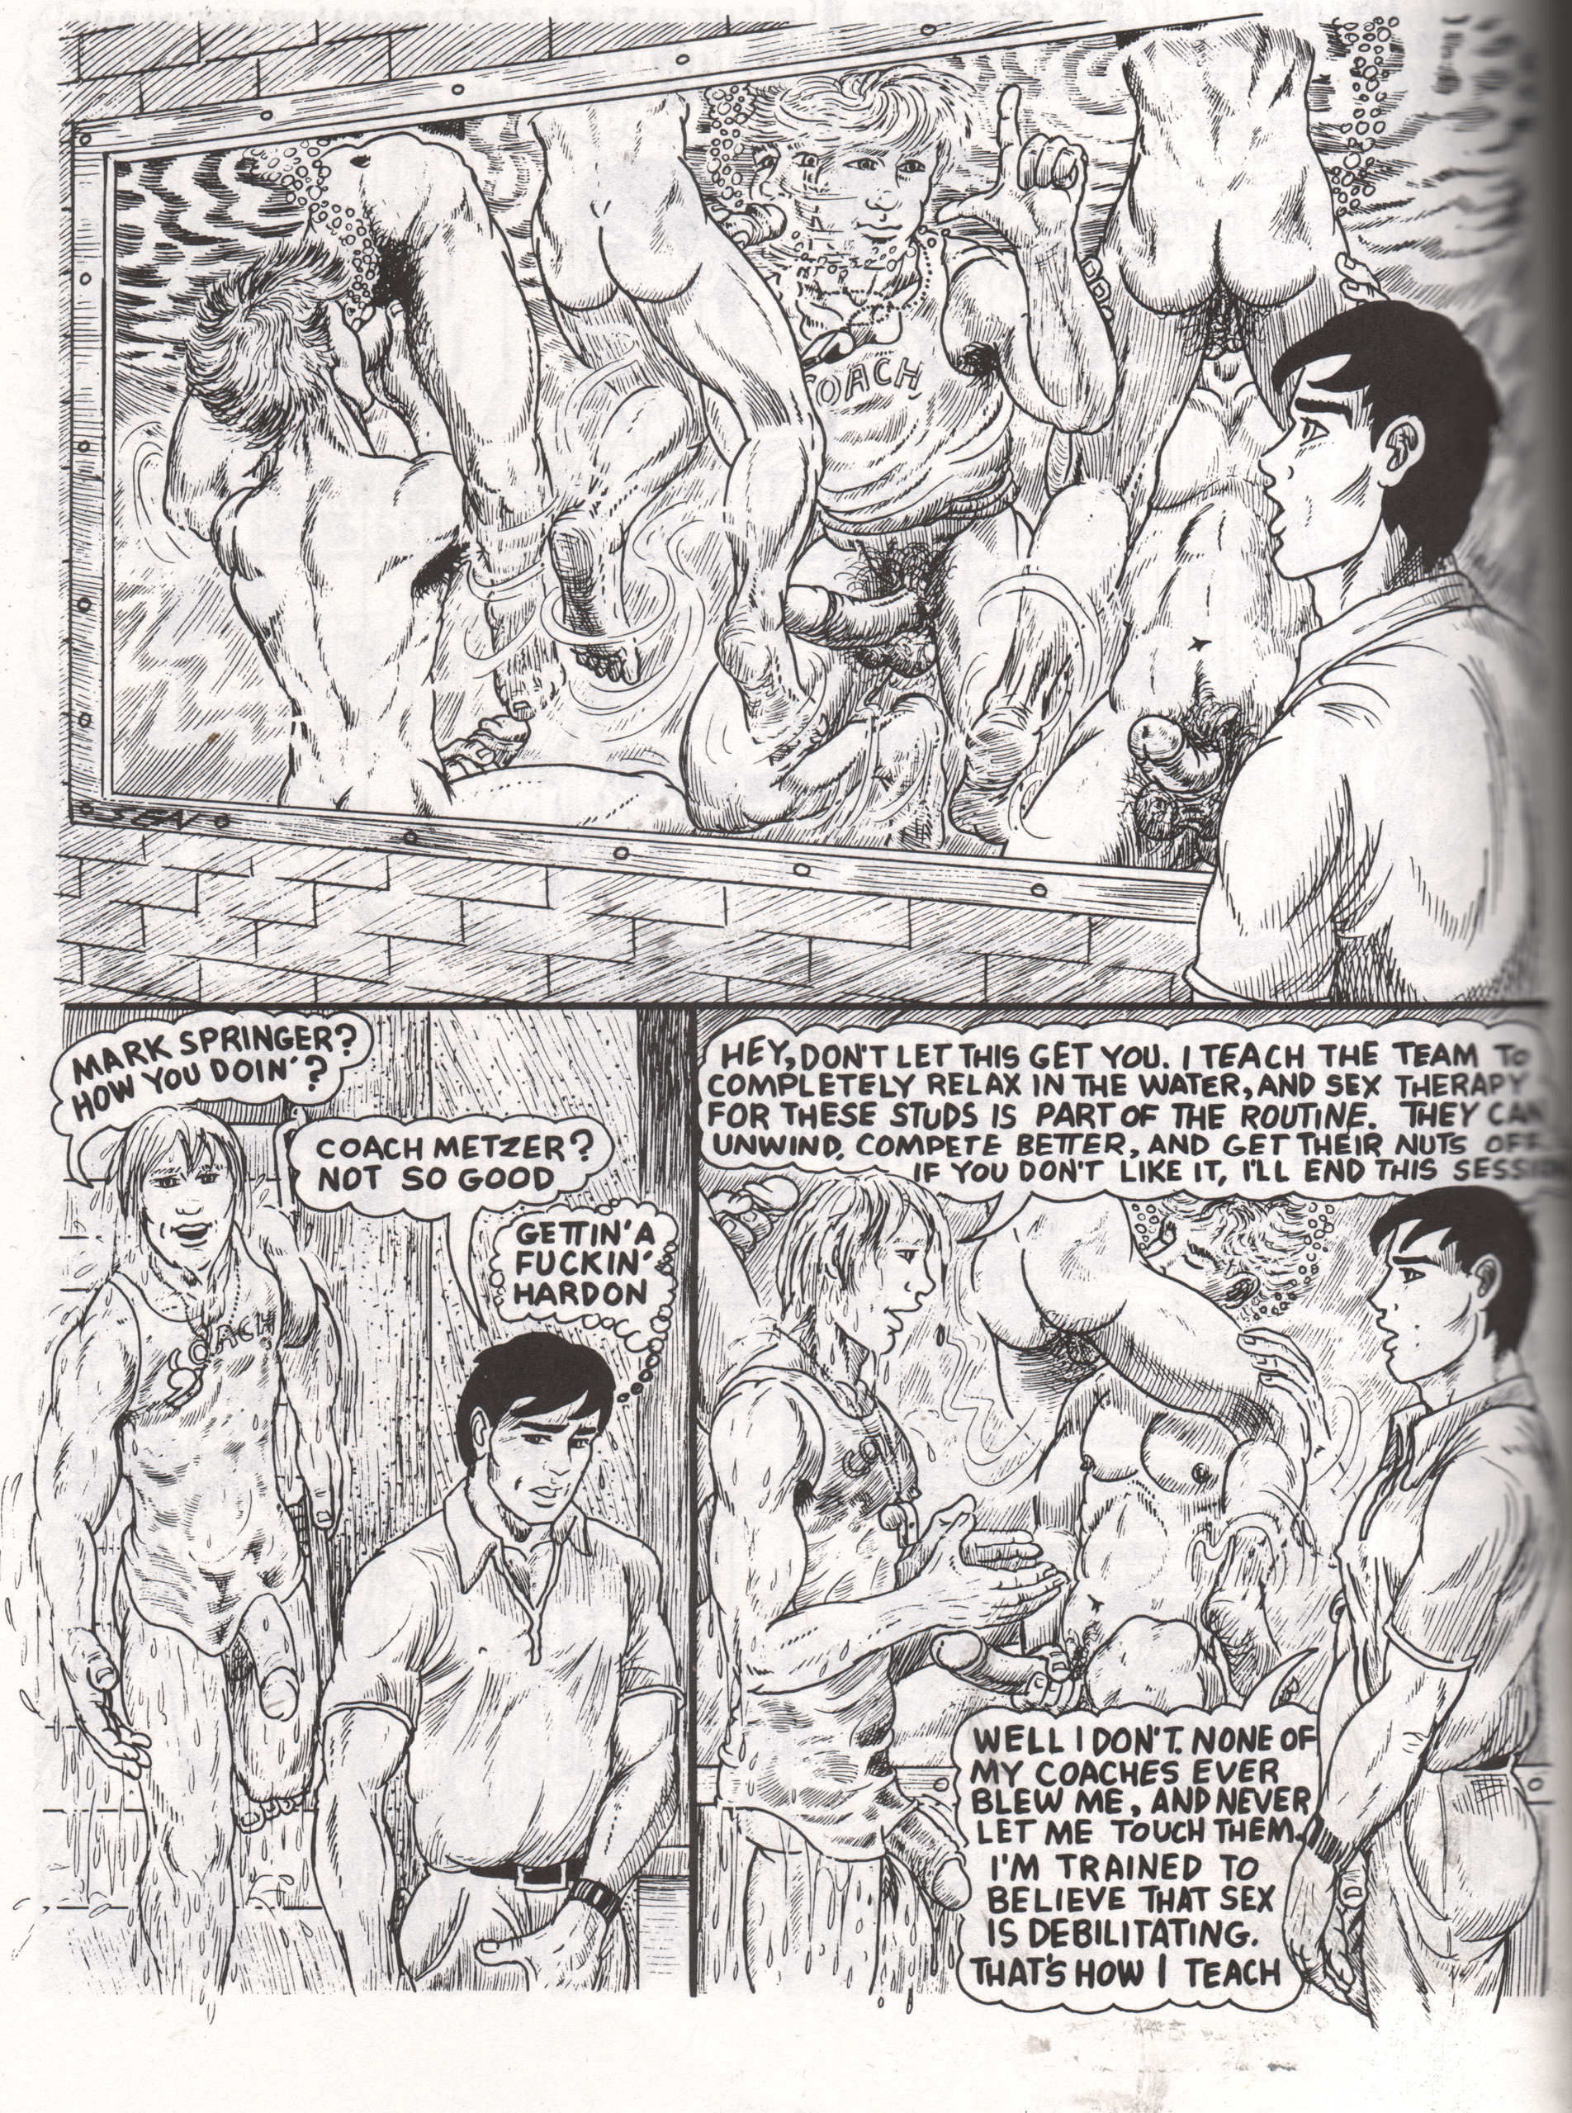
Fig. 1 – Sean (John Klamik), “Swim Meat.” Meatmen Vol. 13, 94.
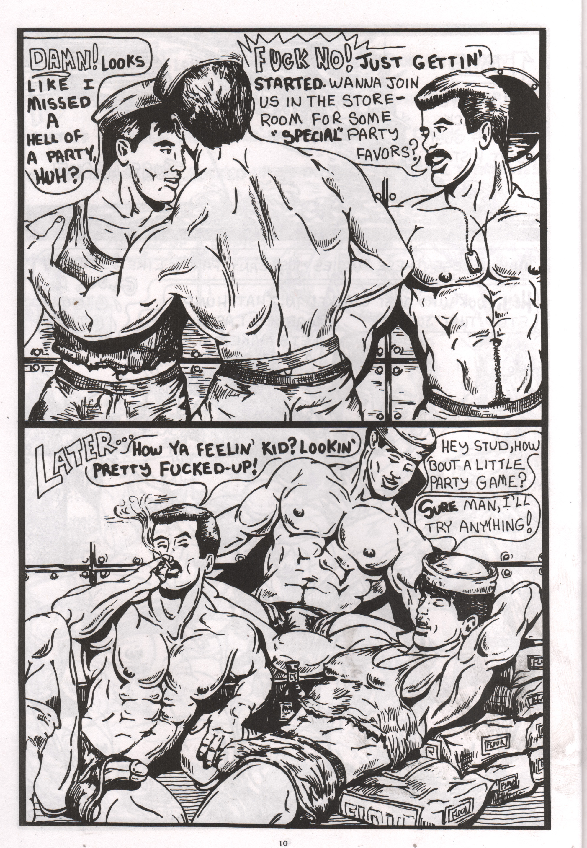
Fig. 2 – Joe’s “Hotshot Seamen: Cumin’ on Board.” Meatmen Vol. 19, 10.
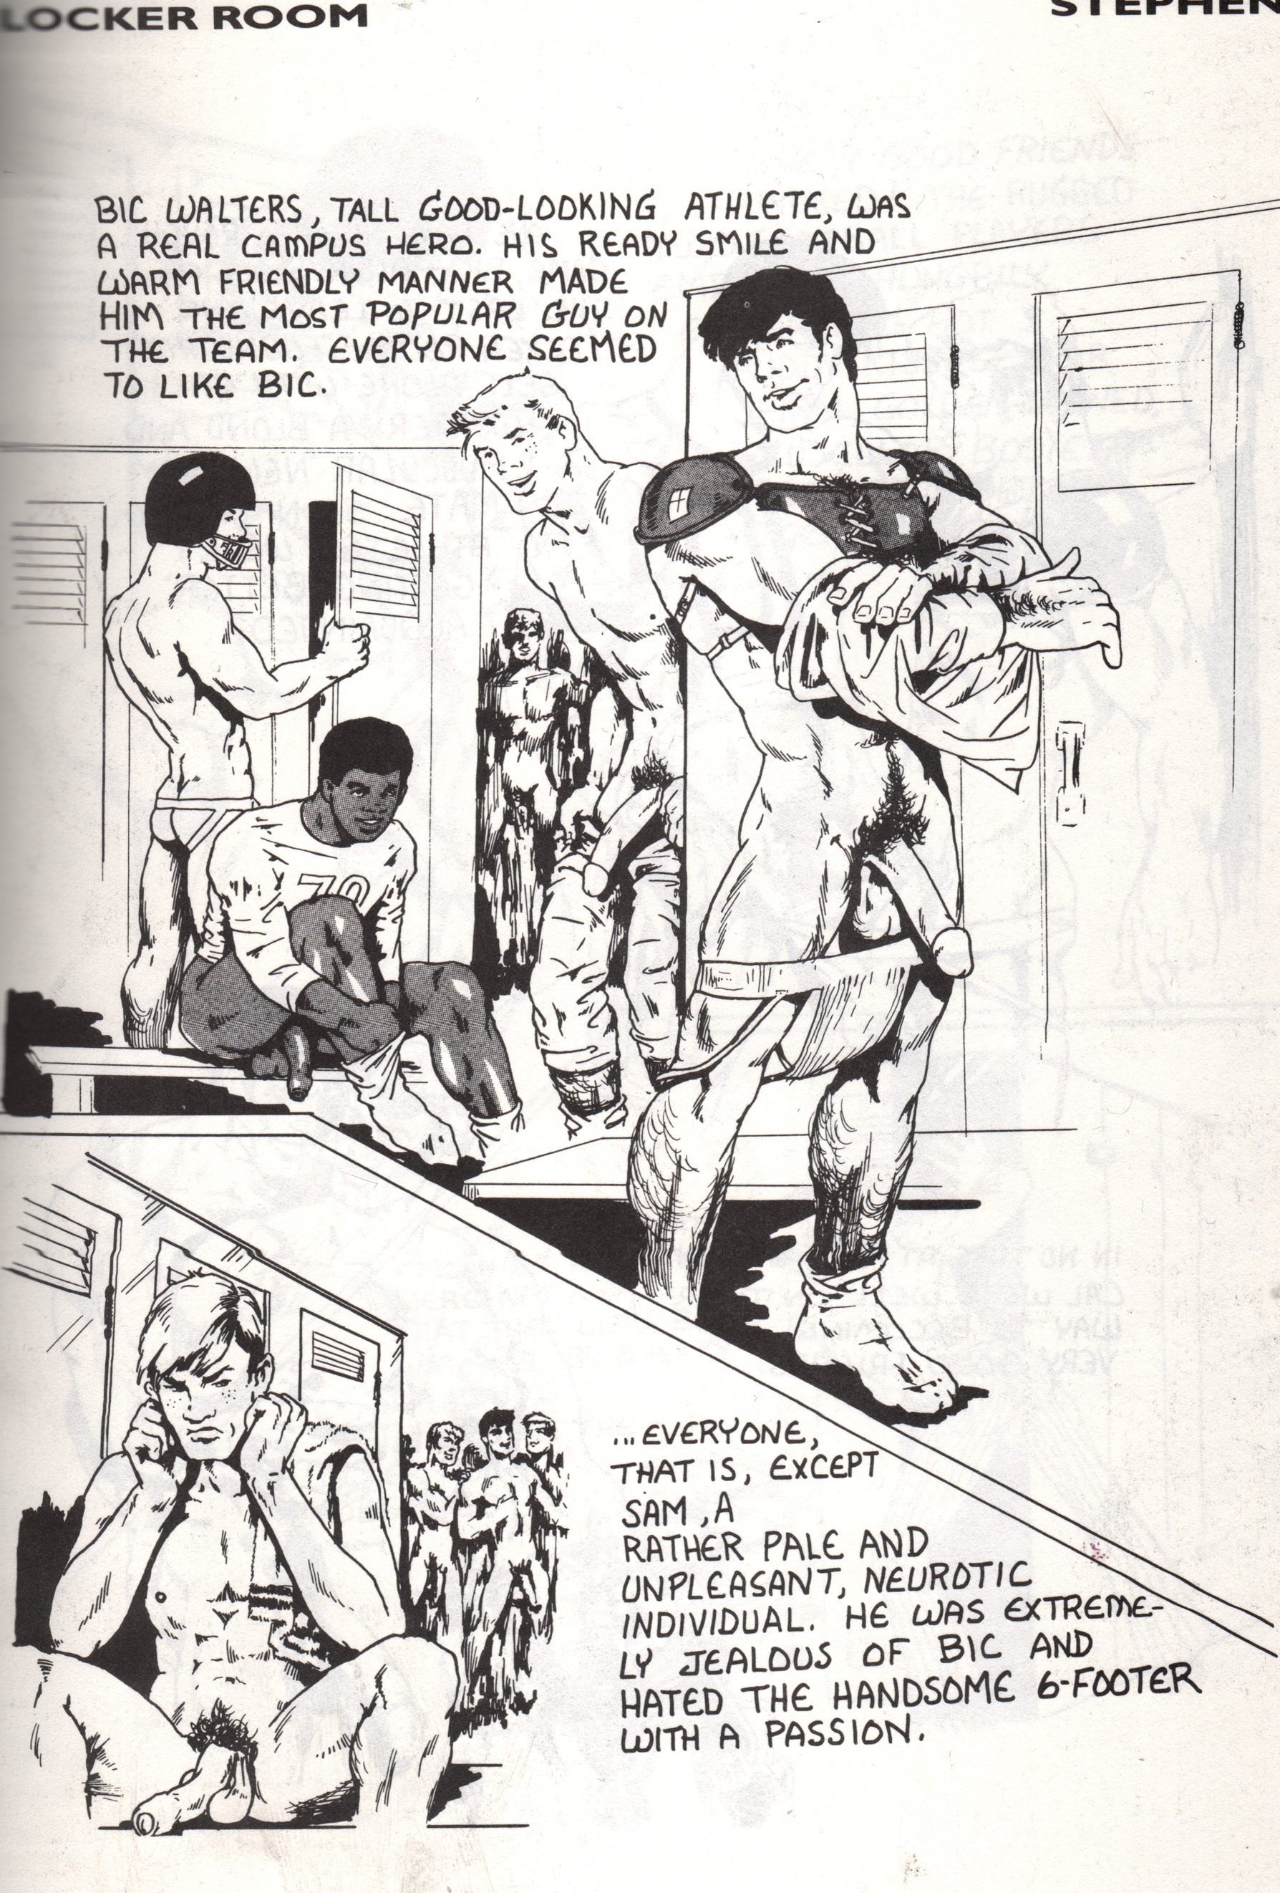
Fig. 3 – Stephen (Dom Orejudos), “Locker Room.” Meatmen Vol. 7, 27.

Mercer contends that while examples of the all-male environment in commercial gay pornography are near-ubiquitous, paradoxically, heterosexual scenarios are also a prominent feature in gay porn. Sometimes this discourse manifests itself in conjunction with that of the all-male environment, with “the red-blooded heterosexual man using the opportunity of gay sex as an outlet for his uncontrollable sexual urges” (Mercer 2004: 157) while at other times we see the ostensibly heterosexual man being inducted into the pleasures of gay sex.
There is sometimes a homophobic element to this discourse, with gay-identified men being humiliated by men who identify as heterosexual and only take the active role in same-sex acts, but there are also examples where homosexuality is affirmed and/or portrayed as superior to heterosexuality, for example when “the straight man discovers, sometimes to his surprise, that gay sex is different from, and possibly better than, its heterosexual equivalent” (Mercer 2004: 158).
Examples of the heterosexual discourse from gay porno comics include Stephen’s “Here Comes the Groom” (1987) in which a handsome professional hockey star drinks a glass of champagne spiked with an aphrodisiac on his wedding night. He is used sexually by a series of men including two sailors and a lifeguard, while his new bride is getting ready in the next room. Realizing he prefers having sex with men, at the story’s end he is dreaming of the sexual encounters he plans to have with other sportsmen on his team. In Farraday’s humorous erotic story “The Adventures of Stud Rollover” (1991) the eponymous gay hero seduces and converts a hunky, homophobic, and heterosexual construction worker while selling him power tools at the construction site. In a more recent example, from Butch McLogic’s Tug Harder (2011-2012), a gay undercover photojournalist seduces his way through a farmyard of dangerous, ostensibly heterosexual men, including ex-convicts.
The next two categories Mercer identifies can be seen as representations validating an autonomous gay lifestyle, albeit a highly idealised one: the urban gay lifestyle discourse, and the luxury fantasy discourse. The first is marked by a celebration of the contemporary urban gay lifestyle, albeit a very particular one, “situated in the West Coast of America” and revolving around “youth, physical beauty, sexual availability and promiscuity” (Mercer 2004: 158). The gay lifestyle depicted is “synonymous with an idealisation of the lives of urban, affluent, Californian, white gay men” (Mercer 2004: 158) who are always young, muscular, attractive, and, of course, horny.
Among the scenarios regularly identified within the urban gay lifestyle discourse are bar and club culture, street life, the gay porn industry, prostitution, and luxuriously appointed domestic arrangements. The luxury fantasy discourse is often deployed in conjunction with the urban gay lifestyle discourse, “deploying a mise-en-scene imbued with either pseudo-classical conceits or, more often, the signifiers of a wealthy and indolent California lifestyle” (Mercer 2004: 160) complete with glamorous locations, swimming pools, beaches, tennis courts, ski lodges and Jacuzzis. In gay porno comics, we find the urban gay lifestyle operating, for example, in Chuck’s “Alex” (1987) which follows the title character’s sexually explicit adventures in gay bathhouses, sex clubs and cruising areas; Zack’s “Slaves to Lust” (2000) and its hero Kyle Jansen, a young rent boy; Brad Parker’s “Bedwyr” (2000) set in a Venice Beach bath house; and the young rent-boy heroes of Mioki’s Side by Side (2008).
The final two categories operate in what Mercer describes as “a more fantastic or metaphysical arena of sexual discourse” (Mercer 2004: 160). Both are often characterised by less emphasis on narrative and more emphasis on elaborately stylised or codified mise-en-scene. These are the discourse of the idyll and the discourse of sadomasochism. The discourse of the idyll “is articulated around ‘back to nature’ scenarios where nudity and exposure to the elements arouse the gay man’s ‘natural’ sexual instincts” (Mercer 2004: 161). Examples from comics are relatively rare but include Sean’s story “Bigfoot and a Half” (1990) about lumberjacks having sex with one another and with the legendary Bigfoot in the forests and mountains of the Northwest.
The discourse of sadomasochistic (SM) fantasy “is invoked in conjunction with almost all the other discursive categories” (Mercer 2004: 161) he identifies. The SM discourse’s “principle characteristics are the use of dungeon settings, the overdetermined iconography of the leatherman and the fetishization of anonymous and/or group sexual encounters” (Mercer 2004: 161) and, often, more extreme sexual practices such as fisting. Examples from gay porno comics are too numerous to catalogue. Every edition of Meatmen featured at least one story that invoked the SM discourse, and volumes eighteen, twenty-four and twenty-six were wholly SM-themed. Sean, Stephen, The Hun, Mike Kuchar and more have all done SM-themed stories. The various titles published by Patrick Fillion’s Class Comics also often feature elements of the SM discourse, most obviously exemplified by the eponymous, leather-clad sex-demon star of Deimos (2011).
In terms of Mercer’s six discourses alone, the gay porn genre in video and comics seem similar, but there are differences. The moving, photographic image of video is distinct from the static, graphic images in comics. Discussing pre-Stonewall gay graphics, the precursor to the contemporary gay porno comics genre, Thomas Waugh argues that the primary operation of a photographed or filmed image is “indexical or documentary,” “intended to arouse through this evidence of ‘real’ bodies, ‘real’ organs, ‘real’ historical subjects” engaged in “real” sexual acts (Waugh 2002: 20). Drawings, instead, “offer a richer spectrum of fantasy . . . often in inverse proportion to their importance as documentary evidence” (Waugh 2002: 20). Comics are more frequently set in fantastical, otherworldly, or futuristic settings. Meatmen devoted volumes twelve and fifteen to sci-fi themes, for example.
The possibilities offered by drawing rather than photography also mean that gay porno comics can depict ever more idealized body types, and represent ejaculation in an exaggerated manner. Dyer writes that the narratives of gay porn film are organized “around the desire to ejaculate” (2002: 145) and Waugh similarly describes ejaculation as “a privileged visual and narrative element” (2002: 34) in the pre-Stonewall graphics he discusses. In the post-Stonewall comics I discuss here, this is no less the case: the majority of stories end with the protagonists drenched in exaggerated floods of ejaculate.
The majority of gay porno cartoonists tend to draw in a style that could be described as relatively “realistic” – this term could arguably be applied to the work of Tom of Finland, as well as Sean, Stephen, Joe, and others. However, Micha Ramakers, discussing Tom of Finland’s work, problematizes terms such as “realistic.” He describes Tom’s work as “part hyperrealist and part caricatural” since on one hand, the level of detail of men’s faces and musculature “suggest[s] a more focused and sharper representation of ‘reality’ than that achieved by any photograph,” whilst on the other, “the systematic exaggeration of certain physical features . . . means that the term cannot be easily applied to the work without losing some of its meaning” (Ramakers 2000: 33-35). The high level of detail and “the sensualist finish” of Tom’s work resulted in drawings that were not strictly speaking realistic, “but rather idealizing representations (sometimes bordering on caricature) of the sexual world” (Ramakers 2000: 35-37).
Artists such as Tom, Sean, Stephen, Joe, and others are comparable to more mainstream comics artists renowned for the relative “realism” of their work, such as Hal Foster (who worked on a Tarzan strip), and Silver and Bronze Age superhero artists like Neal Adams, John Buscema, and John Byrne. Josef Witek classifies such artists as working in “the naturalistic mode” (Witek 2013: 31). The naturalistic is one of the two dominant modes he describes as “the unexamined givens of the profession of making comics” for over half a century; the other is the “the cartoon mode” (Witek 2013: 34). As Witek writes, the naturalistic visual style of comics derives from the conventions of realism in painting and photography, and in the naturalistic mode

. . . the rendering of figures and objects adheres to (or at least points toward) the artistic conventions for creating the illusion of physical forms existing in three-dimensional space. A significant effort is made to create that plausible physical world using shading, consistent lighting sources, texture, and linear perspective (Witek 2012: 31).

The naturalistic mode has long been the preferred approach for comic-book adventure stories in mainstream comic books, especially superheroic adventure, while the “cartoon mode” – growing out of caricature – has most closely associated “humour . . . in comic strips and in gag cartoons” (Witek 2012: 31). The naturalistic mode has also long been the preferred approach for pornographic stories in gay male comics, while the cartoon mode is much more associated with the often more gently humorous gay ghetto genre. This is not to say that there are no examples of gay porno comics that take a “cartoony” approach: The erotic work of The Hun and Mike Kuchar could certainly be described in this way. However, the style of the majority of American gay porno comics tends toward Witek’s naturalistic mode, whereas the gay ghetto comics tend to be somewhat more diverse as well as tending toward Witek’s cartoon mode. The claims I make here of course must be taken to refer to what is generally most usual, and, as Witek notes, the naturalistic and cartoon modes of comics “are by no means mutually exclusive,” and “comics combining elements of both modes are extremely common” (Witek 2012: 34).
Neil Cohn (2013) categorizes the particular kind of “naturalistic” visual style associated with superhero comics as the “Kirbyan dialect” – one of a number of varying styles all found within American comic books and strips. Significant influences on this style include of course Jack Kirby (for whom it is named) but also the likes of Steve Ditko, Gil Kane, Neal Adams, John Byrne, and others (Cohn 2013: 140-141). In the “Kirbyan dialect”, bodies – while in some sense drawn naturalistically – are often physically exaggerated or idealized: “men are more muscular . . . Stereotypically, all figures look like athletes or models” (Cohn 2013: 140-141). The conventionalized male face tends to have “an angular jaw, pronounced cheekbones, and distinct eyebrow muscles” (Cohn 2013: 141). Very similar observations could be made about the kinds of muscular, athletic male bodies most often seen in gay porno comics.
The similarity of the dominant, “naturalistic” – if idealized – styles of mainstream superhero comics to the dominant, idealized “naturalism” of gay porno comics does not seem to be coincidental. One gay erotic illustrator, Felix Lance Falkon, explicitly connects the interest in the muscular physique in homoerotic art with “the proliferation of comic book superheroes – Superman and his myriad of descendants – in costumes that usually revealed every line of their musculature” (Falkon 2006: 59). Falkon discusses how he taught himself drawing “by tracing various well-muscled comic book heroes, leaving off clothing and adding erections of male organs” (Falkon 2006: 121). The Second Wave erotic cartoonist Jon Macy discusses a similar process of learning to draw muscular male figures from superhero comics, in a comic strip titled “Secret Self”: “I loved the artists like Gil Kane who drew men so anatomically correct. I would spend hours lovingly copying the figures and then embellishing them with genitalia” (Macy 1998: 64).
Despite the idealized nature of the bodies depicted, the work of artists like Tom of Finland and others is relatively “realist” in so far as it is grounded in indexical reality, in spite of the richer range of fantastical possibilities that come with the drawn image. Retaining this anatomically plausible realism is perhaps seen as more erotic and arousing, given a historical situation in which the availability of photographic and filmed evidence of “real” bodies, genitals and flesh has arguably conditioned audiences to be more aroused by a more “realistic” style.
The six discursive categories Mercer identifies constitute the basis of what he describes as “a gay mythology” in pornographic video; they “identify and articulate the paradigm of discourses and social settings in which homosexual desire can be situated and manifest itself” (Mercer 2004: 161). Sometimes only one discursive formation is deployed, but more often they are used in conjunction with each other: the discourse of the urban gay lifestyle with that of the luxury fantasy for example, or the discourse of the all-male environment with that of S&M fantasy in military-themed videos. The mythology constructed by gay pornography tells viewers that “there is a plurality to the nature of gay desire,” that there is “more than one form of gay sexual conduct, there are many sets of circumstances in which homosexual desire can manifest itself and, perhaps most significantly, that there is more than one ‘type’ of gay man.” (Mercer 2004: 162-163).
Mercer’s argument challenges critics of pornography who allege that all pornography is damaging and homogenous, best exemplified perhaps by Andrea Dworkin (see for example Dworkin 1991: 56-61). However, I would argue that Mercer overemphasizes plurality. The great majority of the men depicted in gay pornography – including gay porno comics – are white, youthful, slim, athletic, muscular, and “masculine.” Such idealized physiques are such a mainstay of gay porno comics that they might be described as part of the genre’s conventional iconography. Indeed, as noted, it is not just that similar types of men appear but also that they are drawn in a similar way. Tom of Finland’s “prototype” men are one extreme example, but other artists such as Sean, Stephen, The Hun, and Julius all draw very similarly-featured men. Older men, non-whites, men who are too fat, and effeminate men are largely absent from gay pornography.
An ideal “type” of gay man is constructed in pornographic images, whether drawn or photographed, in comic books, magazines, films, videos and so on. However, this image is not exclusive to pornography, nor should pornographic images be singled out for criticism. It is, in fact, part of a broader regime of representation in not only pornographic images but also non-pornographic, non-explicit images of gay men in a range of gay media.
The gay porno comics – like the gay ghetto comics I have discussed elsewhere - are concerned with constructing a variety of norms, and contribute to shaping what Katherine Sender (2004) has called “a dominant gay habitus” (see also Shamsavari 2017a for further discussion of this term.) Both genres generate discourses about what constitutes a “good” or “bad,” “ideal,” and even “authentic” gay identity and habitus. However, in the 1990s, these generic paradigms would start to be questioned by a new generation of LGBT cartoonists emerging against the background of the new, “queer” approach to identity and politics, and influenced by the alternative comics and zine scenes that had been growing throughout the 1980s (Shamsavari 2017b).
Inspired by the burgeoning zine culture’s “do-it-yourself” ideals, new LGBT cartoonists began producing and distributing their work through self-published comics or independent presses. Disinterested in affirming the dominant gay habitus or any strong sense of shared gay identity, the majority of these artists tended to reject the tropes of gay pornography; for example when Robert Kirby inaugurated his anthology Boy Trouble (1994) he made direct reference to Meatmen as a counterpoint to what he wanted to achieve: “All of those over-developed musclemen and throbbing penises (peni?) are fun . . . for a good wank, but most of the stories in the book aren’t useful for much beyond that” (Kirby 1994: np). In contrast, some gay alternative cartoonists embraced the codes and conventions of gay pornographic comics wholeheartedly and created comics that would subvert and redefine the parameters of the gay porno comics genre; the remainder of this article is devoted to discussing these artists.

Alternative Gay Porno Comics

The remainder of this article focuses on what I call “alternative gay porno comics.” These comics by Second- and Third Wave cartoonists take up aspects of the porn genre’s conventions – explicit sex, idealized bodies, and the intention to arouse – but aim to do something different with the genre. This is not to argue that they depart completely from the tropes of the older gay porno comics genre. Alternative porno cartoonists often cite these older artists as influences. Steve MacIsaac, for instance, says that he works “with and against Tom of Finland” (MacIsaac 2008b). Indeed, the same could be said for many of the alternative gay porno cartoonists. The discourse of leather, for example, is prevalent in many of the alternative and mainstream porno comics. However, in stories like Justin Hall’s “Barcelona Booty” (2006) sex scenes in leather clubs are not represented as seamless, successful pornographic scenarios, but include moments of awkwardness and frustration: sex between the protagonist and a leather bar bouncer is constantly interrupted by a stream of bar patrons.
There are other ways in which the alternative gay porno comics do not fully depart from the tropes of the older gay porno comics: for example, the majority of bodies represented in these comics do not tend to be that different from the muscular and athletic bodies portrayed in traditional gay porno comics. That said, there are differences, and in some of the alternative porno comics, especially the stories set in the “real world,” more ordinary bodies are sometimes portrayed.
The majority of alternative gay porno comics are also similar to most traditional ones in style. Most of them stay close to some sense of “realism” in the drawing styles employed, and could be placed within Witek’s “realistic” mode of comics art. This is certainly the case with artists like Jon Macy, Steve MacIsaac, and Justin Hall. However, some, like BiL Sherman and Dave Davenport, do also veer toward a stylized, even slightly abstracted, cartooniness.
In the latter part of this article, then, I argue that over-all, alternative gay porno comics subvert the conventions of the mainstream gay porno comics genre by placing explicit sexual scenarios into more complex emotional narratives. While the characters in the majority of the mainstream gay porno comics are “flat” characters, as previously discussed, the characters in the alternative gay porno comics discussed are more “rounded” and fleshed-out, and we learn more about their relationships and desires, rather than simply watch them in a range of sexual scenarios.
Some of these stories are set in the contemporary, “real” world while others are set in fantastic, otherworldly realms or involve supernatural beings or phenomena. But, whether “realistic” or “fantastical,” these pornographic narratives open up a world of complex human emotions, sexual identities and interrelationships. In emphasizing the emotional dimensions of sex, these alternative porno comics also open up and explore similar territory to the other comics discussed in this thesis, questioning more conventional notions of gay identity and community, as well as binaristic notions of gender and sexuality.
Alternative gay comics contrast, then, with the pornotopias of the majority of gay porn comics, which are usually all-male worlds such as army barracks, locker-rooms and leather dungeons. There, sex is represented purely as a matter of spectacular, visual pleasure; something to be watched and relatively straightforwardly enjoyed, rather than a complex force with the potential to impact on other areas of life and identity.
These comics also question normative notions of gender and sexuality as binaristic, unitary and stable. This may involve focusing on characters who find that their sexual identities, desires and practices do not always line up neatly. In the more “realistic” pornographic comics, such as those by Justin Hall or Steve MacIsaac, this may be a matter of representing characters with more polysexual desires or identities. In the more “fantastic” porno narratives, bodies themselves are represented as hybrid, fluid and unstable.
The kinds of supernatural imagery and tropes used in some of these comics – for example in the work of Jon Macy, Dave Davenport and Brad Rader – is a distinctive departure from the cops, sportsmen and other tropes and character types used in the older gay porno comics. Bodies in the more traditional gay porno comics of Tom, Etienne and so on, remain the same and are often so extremely similar to one another as to constitute “prototypes” (Ramakers 2000: 57). In contrast, bodies in the comics of Macy, Davenport and Rader go through various shifts and transformations.
In the two following sections I will discuss the range of alternative gay porno comics and the different ways in which Second- and Third Wave artists respond to the conventions established by erotic cartoonists of the pre-Stonewall and First Waves. In the section titled “Everyday Sex,” I discuss the work of cartoonists Steve MacIsaac and Justin Hall, who set their pornographic narratives in the “real world,” to show how they present scenes of sex as part of “ordinary” everyday life. In “Supernatural Sex,” I examine the work of Brad Rader, BiL Sherman and Dave Davenport, to demonstrate how they blend the tropes of pornography with those of the fantastic and the supernatural, using the latter as a metaphor for exploring questions of identity, community and sex.

Everyday Sex

Some alternative queer cartoonists respond to the conventions of gay pornography by telling stories of sex set in the “everyday,” contemporary “real world”; Steve MacIsaac and Justin Hall are perhaps the cartoonists who have most consciously used this approach.
Steve MacIsaac’s story “Unpacking” for example, serialized in Shirtlifter, explores the developing relationship between Matt, an openly gay man, and Connor, a married man who views himself as heterosexual and holds many homophobic and gender-normative opinions. One scene from “Unpacking” (Fig. 4) begins by showing a sexual act explicitly, according to the conventions of pornography, but then departs from – and disrupts – these conventions by depicting Matt and Connor’s rather combative discussion about the fact that Connor is married, and refuses to identify as gay or bisexual. “Unpacking” complicates the eroticism of its own imagery by exploring the whole of the relationship in depth, the motivations and the varying perspectives of the two men involved. Matt, for example, is frustrated with the gay dating scene and even though he feels he “should not” get involved with a man like Connor – married, closeted, and homophobic – he does, in part because he has lost faith in the notion of committed relationships with gay men after being unceremoniously dumped after an 8-year relationship.

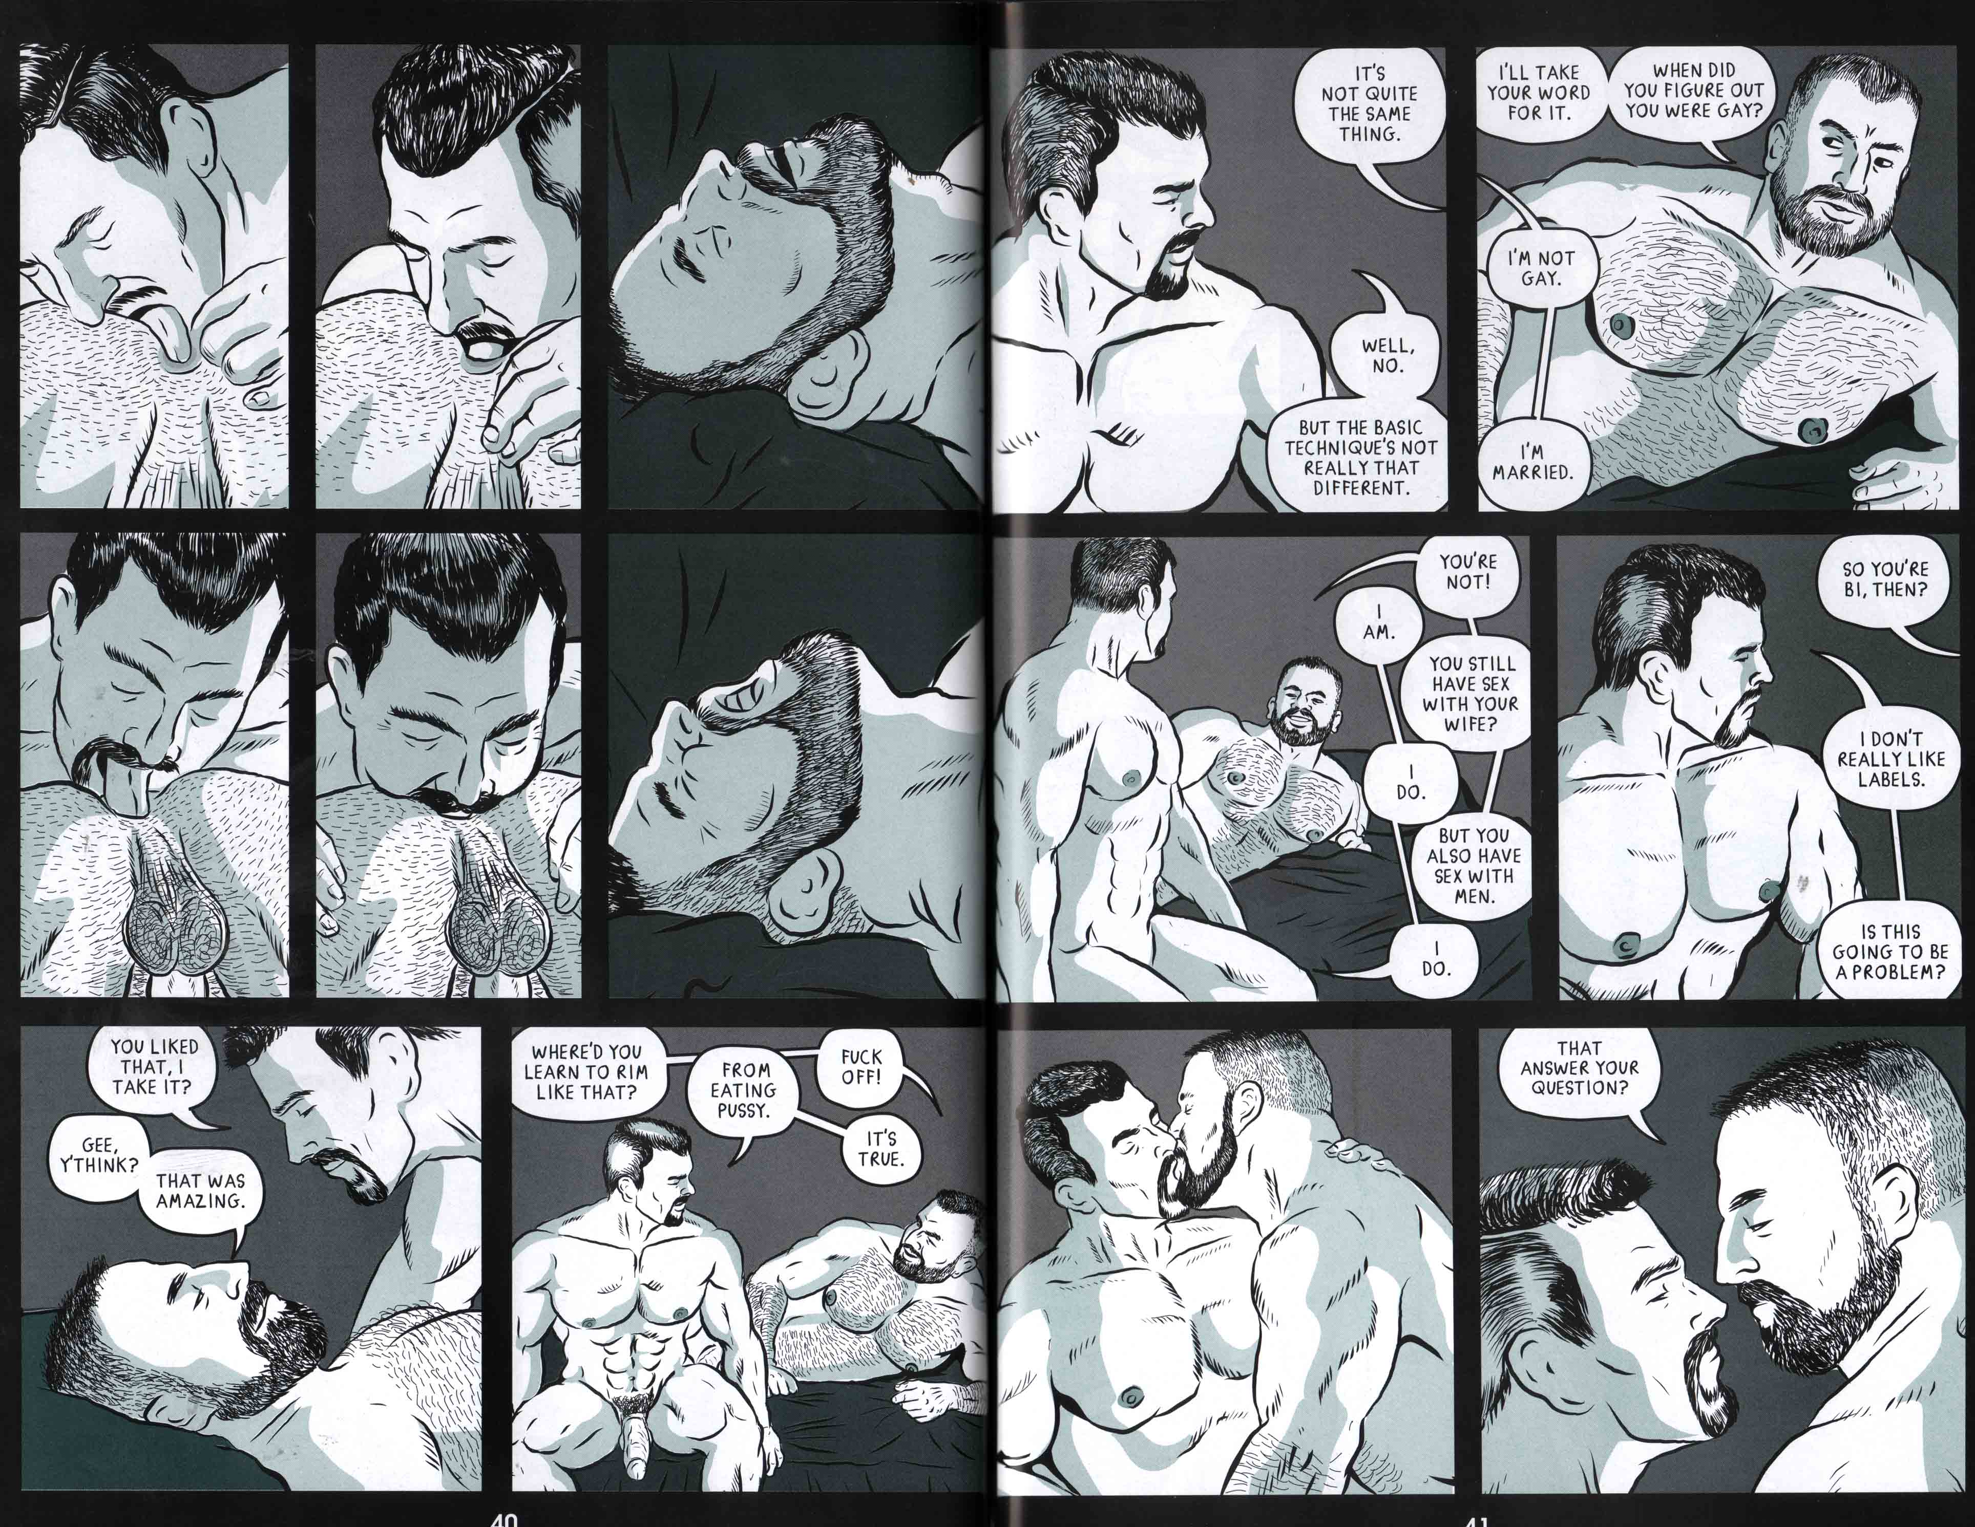
Fig. 4 – Steve MacIsaac, “Unpacking.” Shirtlifter no. 3, 40-41.

Connor’s sexual activities and his view of his identity – as not “gay” or “bisexual” – challenges more conventional assumptions about the way that sexual activity and sexual identity are seen as being congruent. Connor sees his sexual activity with men as being completely different to his relationship with his wife, and is casually homophobic, in one scene refusing to sit next to Matt in the cinema, because it would be seen as “too gay.” This causes Matt first to challenges Connor to kiss him in public and then to fuck him in a side street; the narrative thus takes up the codes and conventions of pornography (public sex and sex with “straight” men are both common themes in gay male porn) but weaves them into a narrative with much more “rounded” characters, the sex revealing more about the characters and their developing relationship as well as arousing the reader.
Justin Hall explores similar territory in his erotic comics that tell the true stories of the private sex lives of people who work in the sex industry. These stories were serialized in the erotic anthology Hard to Swallow (2006-2008), and share some similarities with the gay porno comics genre: graphic sex is shown, and the stories are intended to be sexy. However, there are differences. A broader range of body types and ethnicities tends to be depicted, and sexual desire is often portrayed as surprisingly fluid.
In one story, in fact titled “Fluid” (2007), Hall departs from the conventions of gay porn comics by making the story’s protagonist a woman who engages in sex with gay men. “Fluid” is narrated by “Bang Bang”, a woman who describes herself as a “femme dyke in a committed relationship,” but as the story unfolds we discover that her identity and sexual history are more complex than we might assume. Over a decade ago, Bang Bang “used to strap my tits down, don boy drag, and go to the Powerhouse” – a renowned San Francisco gay male sex club. In a sexually explicit scene, Bang Bang is shown performing oral sex on a hairy older man with a belly – himself a relatively unusual gay porno comics protagonist because of his age and his lack of a lean, muscular body. This scene and the next are very sexually explicit in the tradition of gay pornographic comics, the details of cock-sucking lovingly rendered and focused on, intended to arouse.
Finally the man is shown ejaculating; while in the majority of gay pornographic comics the cum-shot is often the conclusion of the narrative, “Fluid” ends with a twist – as the man helps Bang Bang up off her knees he realizes she has breasts. Initially disturbed by the revelation, he reasons that “It feels nastier to get blown by a woman in the back of a gay bar. And I love nasty!” He thanks Bang Bang with a kiss on the lips and she makes her way home from the Powerhouse in the night, exhilirated.
In some of Hall’s pornographic narratives, then – as in MacIsaac’s - we often find a representation of sexuality as potentially fluid, and he tells a range of stories that shows the variations of queer sexuality, troubling the heterosexual/homosexual binary and the idea that sexual desire and identification are a simple or straightforward matter for everyone. Moreover, because their stories are true or at least naturalistic, MacIsaac and Hall do not simply depict seamless, successful pornographic fucking, instead showing moments of awkwardness and disruption in sex, as well as emotional awkwardness and hesitance in relationships. Both artists, then, use sex to explore character and identity, exposing the vulnerabilities and depicting the humanity of the queer subjects whose sex lives are on display in their comics.
Cohn notes that alternative or independent comics artists tend to employ a kind of visual language he labels the “Indy” dialect; however, there is not one single consistent Indy dialect, but several (Cohn 2013: 143). MacIsaac’s and Hall’s drawing styles fit Cohn’s “second thread of the Indy dialect” best, the thread associated with “serious” narratives. Its common features include “simple, yet straightforwardly

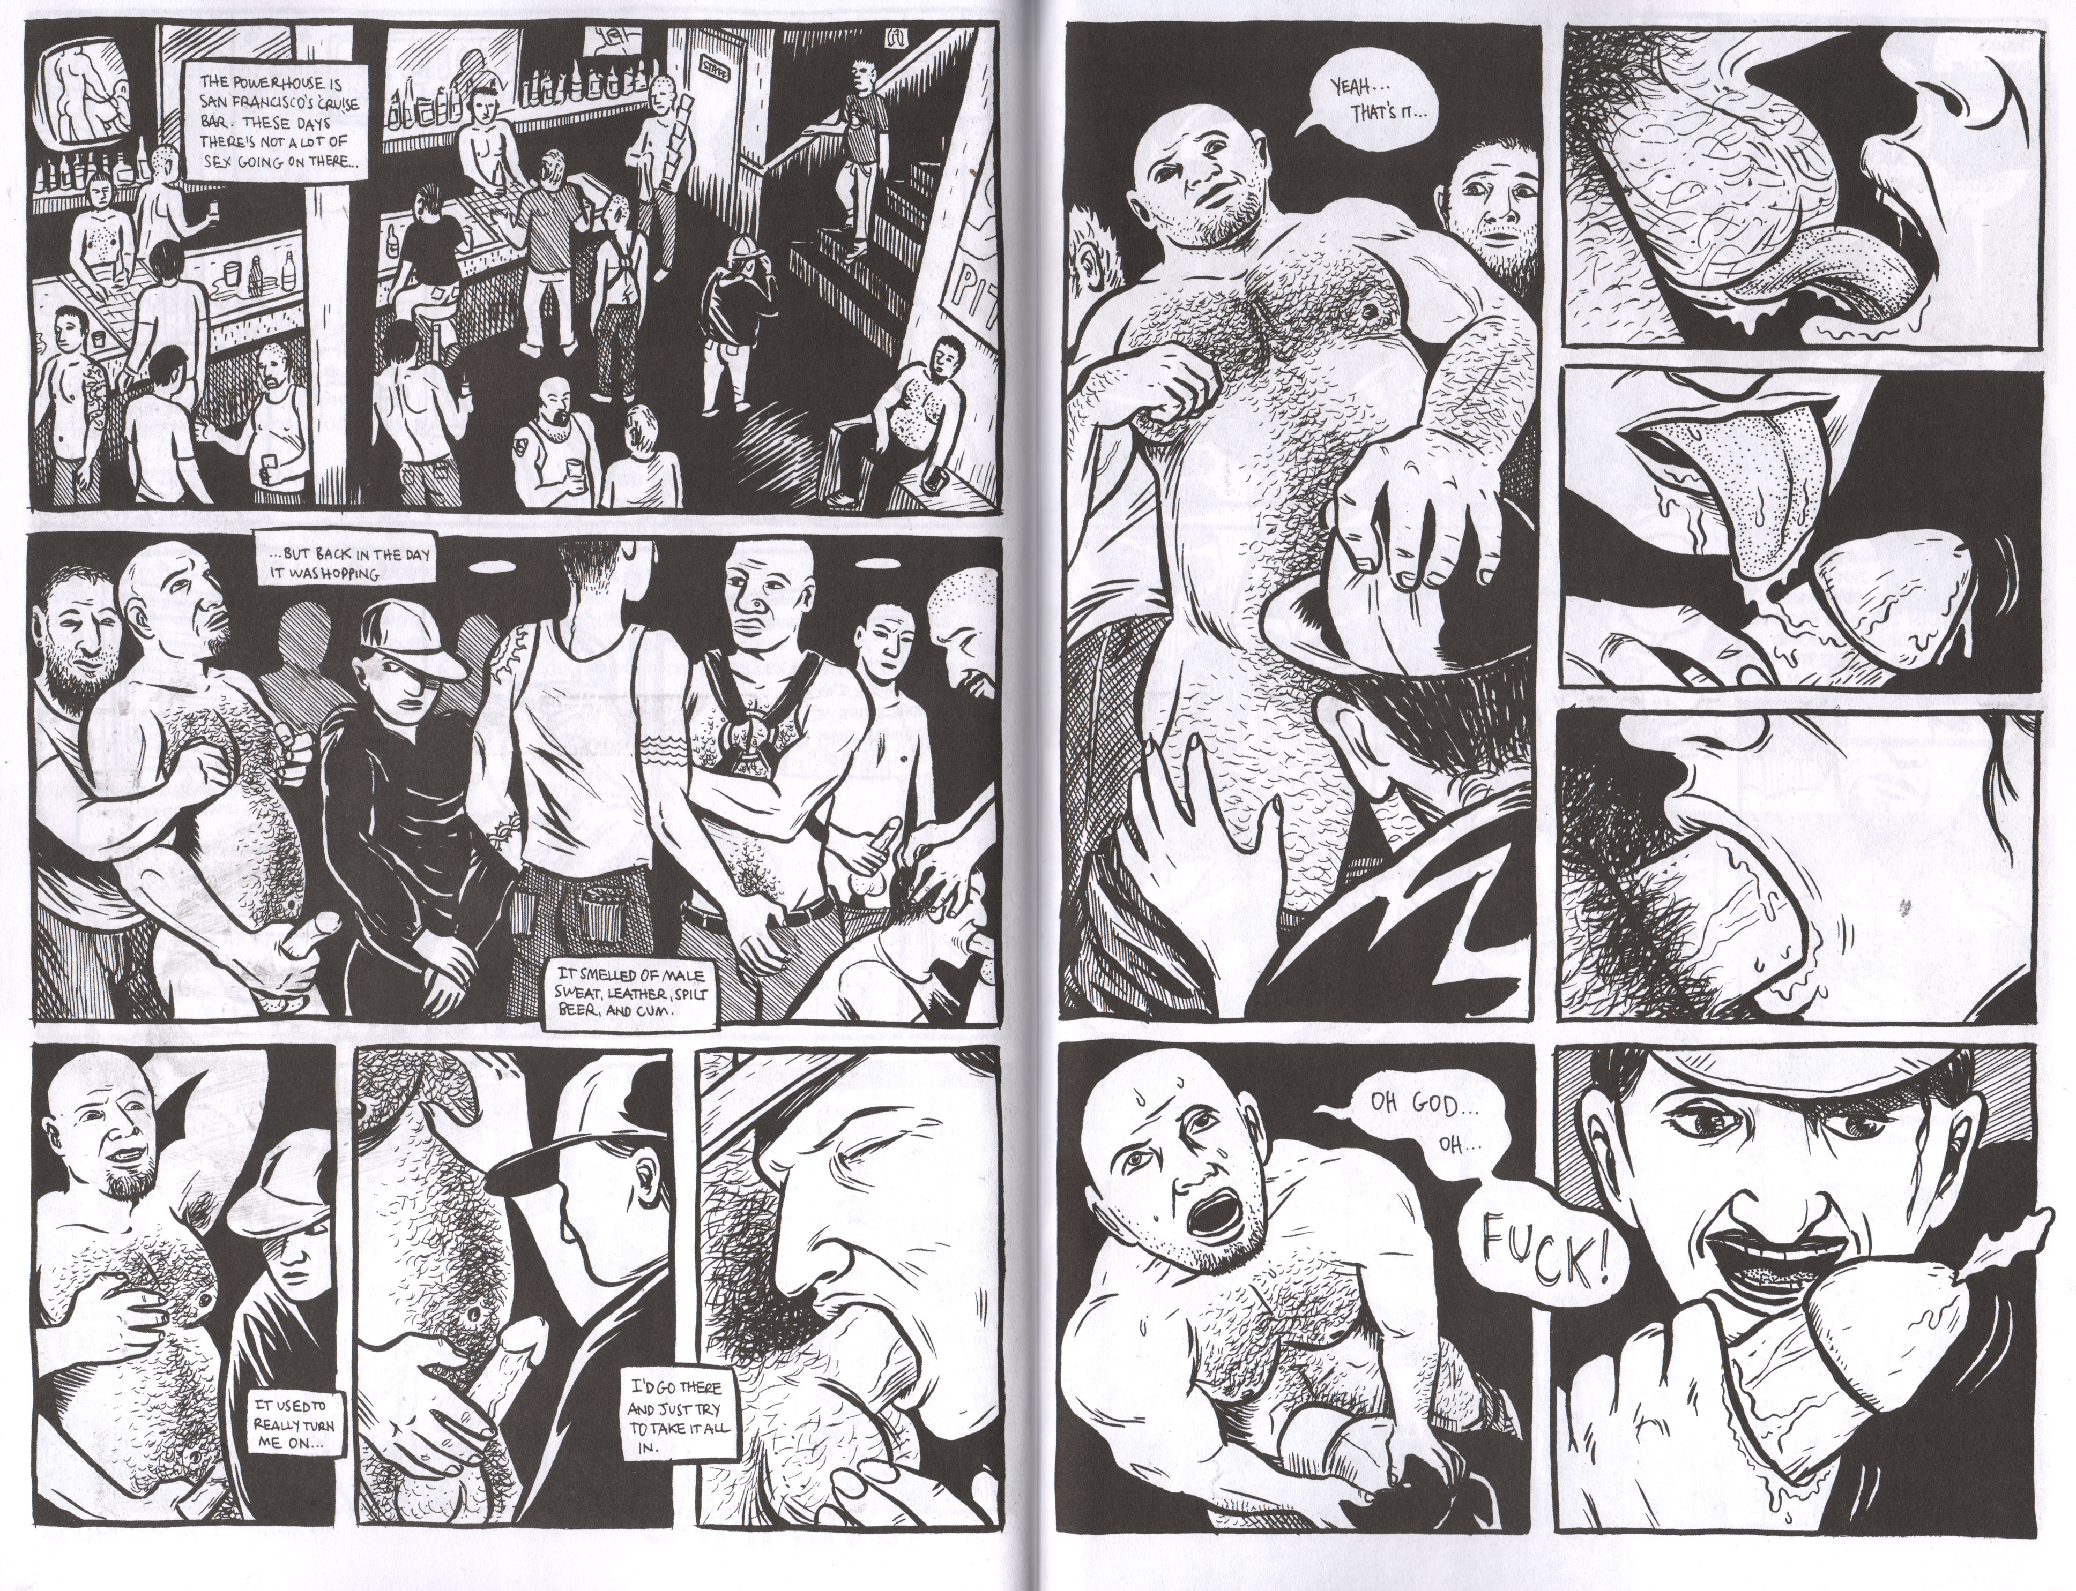
Fig. 5 – Justin Hall, “Fluid.” Hard to Swallow no. 3, 28-29.

realistic drawings,” in which figures usually “retain proportions close to realistic bodies, even accentuating the plainness of people” (Cohn 2013: 143). Cohn notes that these drawings are the antithesis of the “Kirbyan” style, associated with superhero comics, in which bodies are idealized to look “like athletes and models” (Cohn 2013: 141). A similar point could be made, of course, about gay porno comics. In both MacIsaac’s and Hall’s erotic comics there is a tension between idealizing bodies and portraying them in “ordinary” or “naturalistic” ways.
Although MacIsaac’s drawing style is not strictly photorealist, he does use photographic reference for his drawings, sometimes taking his own photographs of men, including himself, and drawing figures based on them (MacIsaac 2008). MacIsaac’s work in Shirtlifter operates in what Witek has called the “naturalistic mode” (Witek 2012: 31-24). The bodies of MacIsaac’s central characters in “Unpacking” are muscular, in line with the athletic bodies seen most often in gay porno comics. However, the faces of his characters are not necessarily those of idealized male models. Furthermore, the other characters in the story are drawn with a range of body and facial types that are often “ordinary” or “plain.” Hall’s drawing style can also be considered as “naturalistic.” He does not use photographic reference as extensively or consistently as MacIsaac. Nevertheless, the faces and bodies he draws tend to retain “realistic” or mimetic proportions, avoiding excessively “cartoony” abstraction. In the “true sex” stories such as “Fluid” (Fig. 5), Hall tends to depict his characters with more “ordinary” or “average” bodies.
Because Hall’s and MacIsaac’s stories are either based on real sexual experiences, or at least intended to seem naturalistic, they tend not to simply depict seamless and successful pornographic sex. Instead, they show moments of awkwardness and disruption in sex and relationships. They use sex to expose the vulnerabilities and depict the humanity of their subjects. This exploration of identity and vulnerability through sex is also the territory of the other main group of alternative gay porno comics artists, whose work I discuss in the next section. In contrast with Hall and MacIsaac, these artists explore such themes in combination with surreal, supernatural settings and motifs.

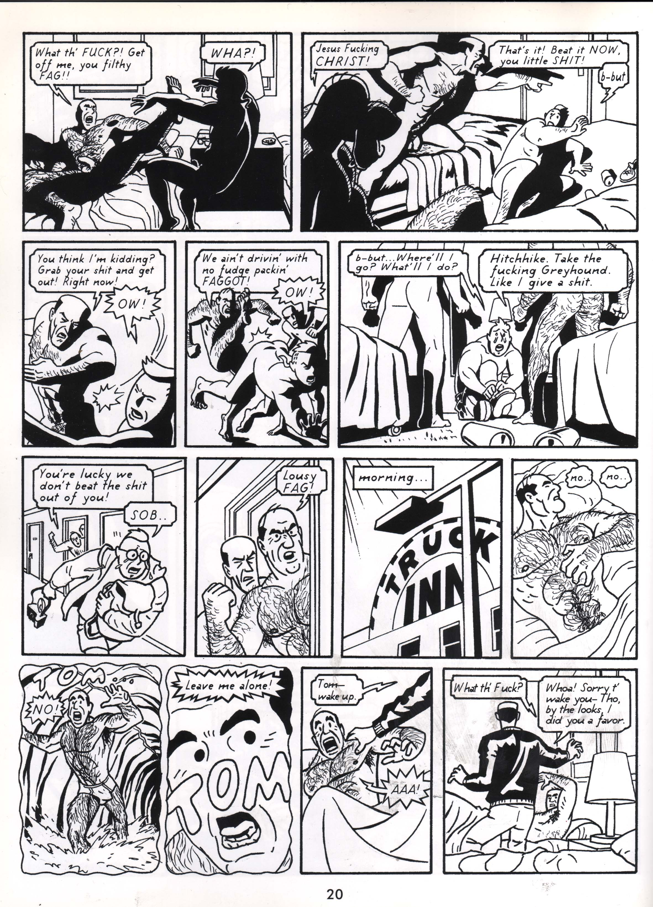
Fig. 6 – Brad Rader, Harry and Dickless Tom, 20.

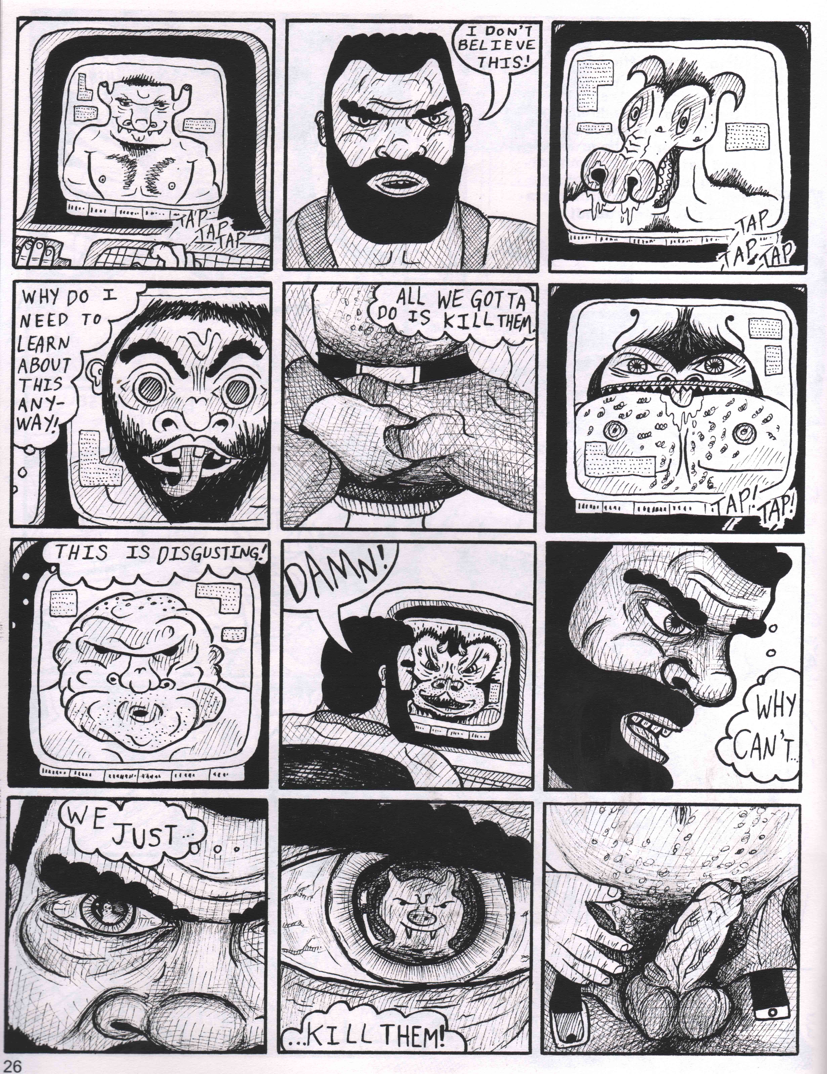
Fig. 7 – BiL Sherman, “Monster War,” Wanky Comics No. 2, 26.

Supernatural Sex

The cartoonists Brad Rader, BiL Sherman, Dave Davenport, and Jon Macy have been some of the main artists of the Second- and Third Waves to blend the tropes of pornography and the supernatural, and they have done so in very different ways. In this section, I show how these cartoonists often use supernatural tropes as a metaphor for exploring questions of sex, gender, and identity.
Brad Rader’s graphic novel Harry and Dickless Tom (2006) tells the story of two friends: married, homophobic, heterosexual truck drivers, Tom Manley and Harry Studman. Each chapter of Harry and Dickless Tom is drawn in a completely different style from the history of comics to suit the chapter’s mood and tone. The first chapter, for example, is drawn in a pastiche of the ligne claire (French for “clear line”) style pioneered by Hergé, the Belgian creator of Tintin (Fig. 6). The innocence of the style matches the wide-eyed innocence of a young, secretly gay art student, Gary, who is interviewing Tom and Harry for his thesis about the lives of truck-drivers. Gary is shocked to find that Tom and Harry have sex with gay men while “on the road” but also violently abuse them. Later. Tom and Harry initiate a threesome with Gary, but when the younger man tries to tenderly kiss Tom, the latter becomes enraged and beats Gary up. As retribution for this, Tom wakes up to discover that his penis has been replaced by a vagina by the “Cunt Goddess,” a supernatural entity who seeks to teach him a lesson for his rigid ideas about masculinity. Harry discovers Tom and his newfound state, and expresses his love for him, leading to Tom punching Harry and then the pair making love.
Subsequent chapters present a variety of transgressive sexual scenarios: Tom having sex with a pre-operative transsexual; Harry discovering his wife having sex with a Black man and then having sex with the man himself; Tom and his wife Rachael having “lesbian” sex with dildos; sex between Tom’s secretly-gay son Lowell and his classmate Martin; and more sex between Harry and “dickless Tom.” Eventually Tom accepts his love-relationship with Harry and his penis is returned to him by the Goddess, and the graphic novel ends with Harry and Tom admitting their love to one another and consummating their relationship as two gay men.
Throughout Harry and Dickless Tom, Rader uses the surreal situation of Tom’s penis being replaced with a vagina in order to explore and address male fears about “femininity” and particularly about taking the passive role in sex – a fear that is rarely addressed directly in gay pornographic comics. The representation of a man with a vagina instead of a penis is certainly transgressive, and is unusual enough in gay pornographic comics to mark Harry and Dickless Tom as “alternative.” Rader also represents a somewhat wider range of body types than are usually found in gay pornographic comics: the men he represents are not the god-like bodybuilders of Tom of Finland and his copyists, but more rough-edged: Harry, Tom, and Coach White, for example, are hairy and muscular but on the stocky side, and older. Of the younger characters, Lowell and Martin are more conventionally slim and athletic, while shy art student Gary is heavier. All the characters – including the female characters - are represented, by the end of the book, naked and in sexual scenarios.
Like Rader, BiL Sherman uses various fantasy tropes in his series Wanky, and particularly in his serial “Monster War”, which – like Rader’s Harry and Dickless Tom – blends pornography and the fantastic to explore – again - fears around sex and identity. The story “Monster War” (2002-2003) follows the adventures of the Captain of a spacecraft of humans engaged in a war against hideous alien monsters.
After the monsters kidnap, rape and mutilate one of the Captain’s men, the Captain finds himself sexually obsessed with them (Fig. 7). In subsequent chapters the Captain is gang-raped by other men on the spaceship, and has various dreams and hallucinations in which he has sex with monsters; finally the Captain is transformed into a monster himself. As Sherman describes, he uses the science fiction trope of violently sexual, grotesque alien monsters as a metaphor for dealing with confronting more kinky or “dark” sexual desires and fantasies a gay man might have: “The things that really turn you on can be scary,” as Sherman (2008) puts it.
The art style Sherman deploys in “Monster War” is crude and brutal, mirroring the savage monsters and the sexual acts depicted therein; even when drawing the supposedly more civilized human beings, Sherman uses thick and jagged dark lines, as well as plenty of cross-hatching, creating grotesque representations of humans and monsters alike that recall the work of underground commix artists such as Robert Crumb. The men Sherman represents are not the handsome, athletic paragons of perfection so often found in gay pornographic comics, but heavier, stockier, and some - in part because of his crude graphic style - might even be described as “ugly” in contrast to the more “heroic” faces and physiques popularized by the Tom of Finland-influenced, “mainstream” gay pornographic comics. Sherman’s thick lines and lumpy, blocky, almost deformed-looking bodies and faces emphasize the fine line between the “human” or “normal,” and the “monstrous” or “deviant.”
Like Rader, and Sherman, Dave Davenport too uses fantastic tropes, combined with pornographic ones, to explore sexual identity, though in a somewhat lighter, more playful vein. As previously mentioned, Davenport collaborated with Justin Hall on an anthology series titled Hard To Swallow (2006-2008) in which Davenport presented various fantastical sexual stories, including the adventures of his triad of central, recurring erotic protagonists: Feral, the Ghost Skater, and Doug. Feral is a man who transforms into a Werewolf whenever he is sexually aroused; Mitch, the Ghost Skater, is the spirit of a skate-punk who was hit by a car while skating on acid; and Doug (also known as “Digit”) is a tattooed, punk rock-loving go-go dancer who was Mitch’s lover while he was alive. The trio are represented as being in an open, three-way relationship, all having sex with one another as well as with other supernatural beings during the course of the storyline. The stories also deal with more serious subjects like gay-bashing and date rape among gay men, albeit in a playful way. For example, in one story – “John I’m Only Dancing” (2008) - Grant, in human form, is drugged and raped by a man he meets in a bar. The rape is portrayed erotically on the first panel of one scene in the story; in line with pornographic tropes, both men’s athletic bodies are rendered sensuously and penetration is shown explicitly (Fig 8). However, Grant wakes up. The date-rape drug having aroused him, he transforms into Feral, taking “revenge” on his attacker by animalistically rimming him.
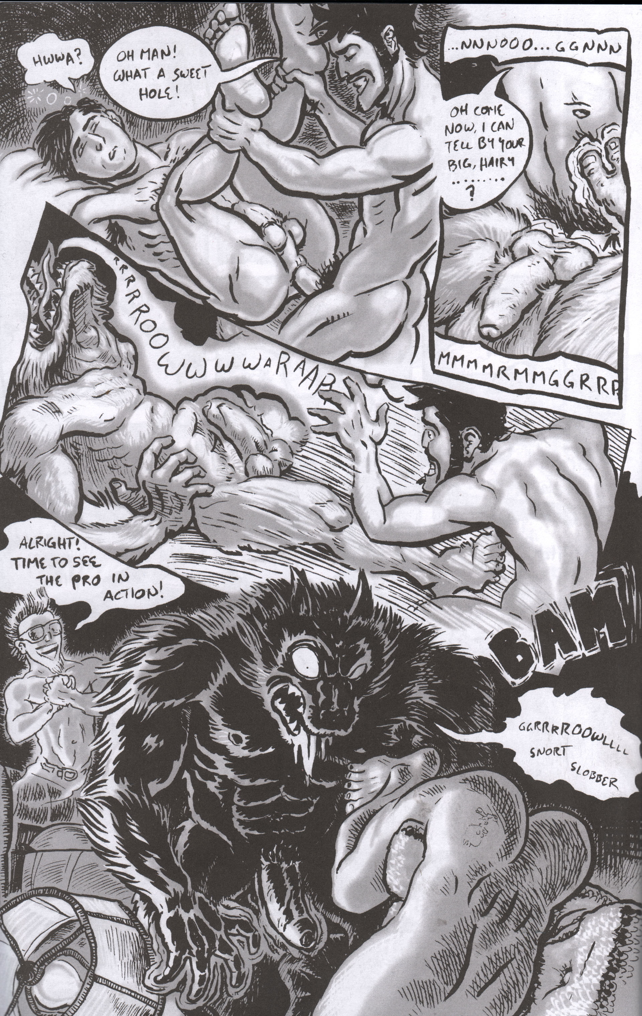
Fig. 8 – Dave Davenport, “Feral: John I’m Only Dancing.” Hard To Swallow no. 4, 10.

The playfulness of Davenport’s narratives is reflected in his drawing style, too, which may be placed roughly between what Witek calls “naturalistic” and “cartoon” modes. For example, in the rape scene described above, Grant’s and the rapist’s bodies are drawn in a way that retains more-or-less realistic proportions, but their faces are more schematized, their eyes for example rendered as simple dots. When Grant transforms into Feral, Davenport’s drawing becomes even more “cartoony” and stylized. The wolf-man’s physique, cock, fur and so on are all drawn in a more playfully exaggerated manner.
Davenport sees these three characters as part of a punk subculture or counterculture, based somewhat on his own experiences in “the gay punk subculture, which was really thriving in San Francisco when I first moved there, and then died out over a few years. [Around] ’88, ’89, there was actually a Homocore movement there, there were gay punk clubs and gay punk shows, and that didn’t happen in very many places in the world” (Davenport, 2008). While he wanted to write about the subculture, davenport felt uncomfortable with straightforwardly autobiographical stories, and eventually fictionalized many of his experiences and made them “the history of Doug and Mitch” (Davenport, 2008).
Davenport deliberately tried to go against the grain when designing these characters’ body types and looks: Mitch the Ghost Skater is very skinny, with tattoos and a Mohawk, and Doug is muscular but not defined, and short – roughly 5’5” – and unlike most gay pornographic characters, as Davenport puts it, “doesn’t have a big dick” (Davenport, 2008). Of the trio, the werewolf Feral is perhaps the closest to a Tom of Finland type – tall, muscular, and sexually aggressive – but he is covered with fur, with a tail and an enormous snout.
The figure of the werewolf is attractive to Davenport because it “represents primal urges and lack of inhibition” (Davenport, interview). Davenport also credits the earlier, first-wave gay cartoonist Brad Parker with inspiring the character of Feral; in the 1980s Parker did a story, published in Strip AIDS USA, in which becoming a werewolf cures people of AIDS. The figure of the werewolf also recurs in the erotic comics of Jon Macy, arguably the most accomplished creator amongst the “alternative gay porno” cartoonists, with a large body of pornographic work in which the supernatural is used as a metaphor for exploring queer identity and sexuality.
Werewolves appear in Macy’s early story “Tail” (1997) – published in Meatmen - and in his later series Fearful Hunter. In “Tail,” the main protagonist – known as the “Wolf-boy”- is tortured by his high-school gym coach (whom he loves) and sexually humiliated by his classmates, eventually being transported to an otherworldly, erotic landscape and finally meeting the coach again in a moonlit glade, to find he has become wolf-like himself and returns the Wolf-boy’s passion (Fig. 9). Fearful Hunter tells the story of a romantic relationship between the trainee druid Oisin and the troubled werewolf Byron. The characters in Fearful Hunter take on various animal-like attributes and have sex
with monstrous supernatural gods, and Byroin is portrayed as a member of a “pack” of wolf-like humans who couple in same-sex pairs in the forest. The werewolf is an example of the cinematic horror trope of “the seemingly ‘normal’ man who becomes a monster or has a hidden monstrous self” and one of “several 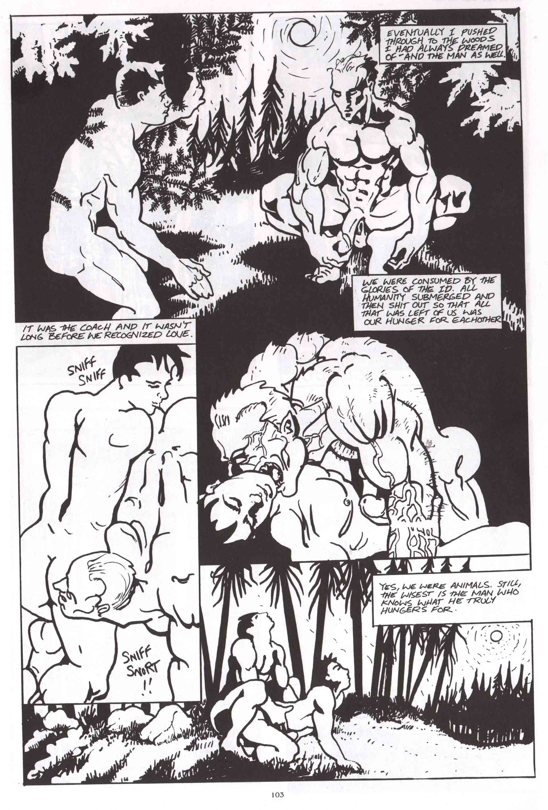
Fig. 9 – Jon Macy, “Tail.” Meatmen Vol. 21, 103.
iconographic queer monsters” produced by Hollywood during the classical period (Benshoff 1997: 47-48). The homosexual undertones of these queer monsters “would become more and more prevalent as they were remade and adapted across the years” (Benshoff 1997: 47), and Macy’s use of the werewolf is one of these adaptations -albeit outside of the world of Hollywood cinema - that makes the figure’s queer undertones explicit. Werewolves in both Macy’s and Davenport’s work are queer figures that challenge culturally-constructed binary oppositions between human and animal, civilized and uncivilized, and hetero and homo.
Similarly to Rader and Sherman, both Jon Macy and David Davenport’s comics represent alternative, fictional worlds in which queer characters routinely interact with supernatural forces, often sexually. Both writers create their own personal fantasy worlds, albeit based in reality. Davenport, for example, combines elements of supernatural mythology with his own fond memories of his experiences in the gay punk subculture in towns like San Francisco: “I’m just putting this little world together that I’d wanna live in myself, I guess… that’s the best way to put it, this is my perfect world... It’s my fantasy” (Davenport, 2008). Macy’s work also draws on his own experiences of living in San Francisco, combining these with alternative, supernatural worlds. Fearful Hunter, for example, is in one sense the story of Macy and a troubled former lover (whom the werewolf Byron is based upon.) During my interview with Jon Macy, his friend Karine Collet (a dramatist who adapted some of his work into stage productions) commented that Macy’s work
was kind of like punk, but I remember it was like the surrealists, making another reality and making that manifest itself in this world, like changing, your work was creating a new world, and it’s what we always talked about, whether it was in theatre or in movies, the things that we loved was, pulling people out of this world, and not just going to the past or the future but a different world, and that’s what your stories were very much about, were going to another world, creating another world [ . . . ] and that was very political in its own way (Macy and Collet, 2008).
Macy and Davenport, along with Sherman and Rader, could be said to be engaged in the kind of utopian queer world-making described by José Esteban Muñoz (2005). For Muñoz, utopia “lets us imagine a space outside heteronormativity” and “offers us a critique of the present, of what it is, by casting a picture of what can and perhaps will be” (Muñoz 2005: 35). Muñoz argues that memories and their ritualized retellings through writing, performance, and visual culture, have “world-making potentialities” and can “help us carve out a space for actual, living sexual citizenship” (Muñoz 2005: 35).
Certainly, Davenport’s and Macy’s erotic queer worlds as created and built in their comics, splice together their own memories and experiences with fantasy – both in the sexual and the otherworldly, supernatural sense. For Muñoz, gay male writers who document their sexual experiences are critiquing the limits and barriers of the present, “pointing beyond the barriers of our current conditions of possibility, beyond the painful barriers of the AIDS pandemic”, beyond the “what is” of the present to “worlds of political possibility, of ‘what might be’” (Muñoz 2005: 38).
I would argue, extending this, that gay male comics creators of who document both sexual experiences and fantasies are also utopian, in that creating such a queer sexual archive of both experience and imagination, invites openness and discussion in a public arena, as well as generating pleasure. Queer comics which are explicitly sexual – whether documenting real experiences or depicting realistic ones (as Hall’s and McIsaac’s do), or building utterly fantastic worlds (as Rader, Sherman, Davenport and Macy do) – resist heteronormative repression, creating alternative realities.

Conclusion

The alternative erotic comics discussed in the latter part of this article take up the conventions of the gay porno comics genre – idealized male bodies, explicit sex – and are certainly influenced by the older generation of gay erotic cartoonists including figures like Sean, The Hun, and particularly Tom of Finland. In Steve MacIsaac’s words, alternative gay erotic cartoonists work “with and against Tom of Finland” (MacIsaac 2008b). Alternative erotic comics depart from the conventions of the genre in a number of ways. Characters are presented as complex and “rounded,” and sex – while shown explicitly and intended to be arousing – is also presented as part of a broader and more complicated narrative.
As part and parcel of this concern with complex identities and narratives, many of the alternative gay comics are somewhat critical of queer communities, with Hall’s and MacIsaac’s stories, for example, often representing a complicated and not always celebratory view of the gay communities they are set within.
Along with this somewhat sceptical view of gay community, then, comes a concern with showing the complexity of sexual identities, desires, and practices. This is done relatively straightforwardly in those comics set in the “real world.” For example, in Justin Hall’s true sex stories a gay male escort has a threesome with a married heterosexual couple, or – in the example discussed above – a lesbian woman tells of dressing in boy drag to have sex with gay men in sex clubs. In comics by artists like Brad Rader, BiL Sherman, and Jon Macy, the complexity of sexual desire is shown metaphorically, through gender transformations and human/animal hybridity.
Queer male cartoonists who work with the gay porno genre and seek to create sexually exciting comics narratives, also work to explore the complex nature of sexuality, identity and community, emotions and relationships, in ways that broaden the possibilities of what gay porno comics can do. Gay male pornographic comics generally – and the alternative gay porno comics in particular - critique the heteronormativity of the “straight world” and resist repression. As Muñoz describes, any kind of queer cultural production “is both an acknowledgement of the lack that is endemic to any heteronormative rendering of the world and a building, a ‘world making,’ in the face of that lack” (Muñoz 2005: 118). Utopianism is “both a critique and an additive or reparative gesture. Queer utopian practice is about ‘building’ and ‘doing’ in response to that status of nothing assigned to us by the heteronormative world” (Muñoz 2005: 118). The queer utopian practice of alternative gay porno comics challenges not just heteronormativity – though it certainly does that – but also, potentially, the norms and conventions of the gay male porno comics genre.
Bibliography
Benshoff, Harry M. 1997. Monsters in the Closet: Homosexuality and the Horror
Film. Manchester: Manchester University Press.

Bourdieu, Pierre. 1984. Distinction: A Social Critique of the Judgement of Taste,
Cambridge: Harvard University Press.

Bourdieu, Pierre. 1993. The Field of Cultural Production, Cambridge: Polity.

Chasin, Alexandra. 2000. Selling Out: The Lesbian and Gay Movement Goes to
Market. New York: Palgrave.

Christensen, Charles “Zan”, ed. 2013. Anything That Loves: Comics Beyond “Gay”And “Straight.” Seattle, WA: Northwest Press.

Chuck. 1987. “Alex.” In Meatmen Vol. 2, edited by Winston Leyland, 158–163. San Francisco: Leyland Publications.

Cohn, Neil. 2013. The Visual Language of Comics: Introduction to the Structure and Cognition of Sequential Images. London: Bloomsbury.

Cooper, Dennis. 1996. “Queercore.” In The Material Queer: A LesBiGay Cultural
Studies Reader, edited by Donald Morten, pp. 292-296. Boulder, Colorado and Oxford: Westview Press.

Cruse, Howard. 1980. “Billy Goes Out.” In Gay Comix no. 1, edited by Howard Cruse, np. Princeton, WI: Kitchen Sink Press. Reprinted in No Straight Lines, edited by Justin Hall, pp. 38-44. Seattle, WA: Fantagraphics, 2012.

Cruse, Howard. 1982. “Dirty Old Lovers.” In Gay Comix no. 3, edited by Howard Cruse, np. Princeton, WI: Kitchen Sink Press.

Cruse, Howard. 1998. “Editor’s Notes.” In Gay Comics no. 25, edited by Andy Mangels, p. 3. San Francisco, CA: Bob Ross.

Cruse, Howard. From Headrack to Claude: Collected Gay Comix by Howard
Cruse. North Adams, MA: Nifty Kitsch Press, 2009.

Cruse, Howard, ed. Gay Comix no. 1–4. Princeton, WI: Kitchen Sink Press,
1980-1983.

Cruse, Howard. 1976. “Gravy on Gay.” In Barefootz Funnies no. 2, np. Princeton, WS: Kitchen Sink Press.

Cruse, Howard. Stuck Rubber Baby. New York: Paradox Press, 1995.

Cruse, Howard. 2001. Wendel All Together. Chicago, Illinois: Olmstead Press.

Cvetkovich, Ann. 2003. An Archive of Feelings: Trauma, Sexuality, and Lesbian
Public Cultures. Durham: Duke University Press.

Davenport, Dave. 2008a. “John I’m Only Dancing.” Hard to Swallow no. 4, edited by Justin Hall and Dave Davenport, 1-14. San Francisco and Los Angeles, CA: Marginalized Publications/All Thumbs Press.

Davenport, Dave. 2008b. Interview with author, Los Angeles, CA, July 31st.

Davenport, Dave. Feral and the Ghost Skater No. 1. Los Angeles, CA: Marginalized Publications, Spring 2011.

Du Plessis, Michael, and Kathleen Chapman. 1997. “Queercore: The Distinct
Identities of Subculture.” In College Literature 24, no. 1, pp. 45-58.

Duncombe, Stephen. 1997. Notes from Underground: Zines and the Politics of
Alternative Culture. London and New York: Verso.

Dworkin, Andrea. 1991. “Against the Male Flood: Censorship, Pornography and Equality.” In Pornography: Private Right or Public Menace, edited by Robert M. Baird and Stuart E. Rosenbaum, 56–61. New York: Duke University Press.

Dyer, Richard. 1991. “Believing in Fairies.” In Inside/Out: Lesbian Theories, Gay
Theories, edited by Diana Fuss, 185-201. New York: Routledge.

Dyer, Richard. 2000. “Coming To Terms.” In Only Entertainment, Second Edition, pp. 138-150. London: Routledge.

Dyer, Richard. 2002. The Culture of Queers. London: Routledge.

Dyer, Richard. 2002. “Introduction.” In The Culture of Queers, pp. 1-14. London: Routledge.

Dyer, Richard. 2000 (first published 1992.) Only Entertainment, Second Edition. London: Routledge.

Edwards, Tim. 1994. Erotics & Politics: Gay Male Sexuality, Masculinity and
Feminism. London: Routledge.

Edwards, Tim. 2006. Cultures of Masculinity. London and New York: Routledge.

Fahy, Michael. 2004. “Dumbass.” In Boy Trouble no. 4, edited by Robert Kirby and David Kelly, np. Seattle, WA: DK Press. Reprinted in The
Book of Boy Trouble, edited by Robert Kirby and David Kelly, p. 41. Sa Francisco, CA: Green Candy Press, 2006.

Fahy, Michael. 1996. Litany. Philadelphia, PA: Self-published.

Fahy, Michael. 2007. Ten Thousand Dreams Interpreted. Philadelphia, PA: Self
published.

Falkon, Felix Lance, and Thomas Waugh. 2006 (first published 1972). Gay Art: A Historic Collection, Revised edition. Vancouver, BC: Arsenal Pulp Press.

Farraday. 1991. “The Adventures of Stud Rollover.” In Meatmen Vol. 10, edited by Winston Leyland, 63–80. San Francisco: Leyland Publications.

Fenster, Mark. 1993. “Queer Punk Fanzines: Identity, Community, and The
Articulation of Homosexuality and Hardcore.” In Journal of Communication Inquiry 17, no. 1, pp. 73–94.

Fillion, Patrick. 2011–2014. Deimos no. 0–2. Coquitlam, British Columbia: Class Comics.

Fillion, Patrick ed. 2011. Heroes with Hardons: The Big Book of Class Comics. Berlin: Bruno Gmünder.

Fillion, Patrick. 2011. The Incredibly Hung Naked Justice no. 1–2. Coquitlam, British Columbia: Class Comics.

Forster, E.M. 2005 (first published 1927). Aspects of the Novel. London: Penguin, 2005.

Foucault, Michel. 1972. The Archaeology of Knowledge. New York: Pantheon Books.

Foucault, Michel. “The Order of Discourse.” In Untying the Text: A Post
Structuralist Reader, edited by Robert Young, pp 48–78. Boston: Routledge & Kegan Paul.

Foucault, Michel. 1984. “Truth and Power,” interview with Alessandro Fontana
and Pasquale Pasquino. In The Foucault Reader: An Introduction to Foucault’s Thought, edited by Paul Rabinow, pp. 51–75. London: Penguin.

Foucault, Michel. 1981 (first published in 1978). The Will to Knowledge: The History of Sexuality, Vol. 1. Translated by Robert Hurley. Harmondsworth: Penguin.

Foucault, Michel. 1975. Discipline and Punish: The Birth of The Prison, London: Penguin Books.

Fraser, Robert and Joseph Hawk. The Initiation: Higher Sex Education no. 1–3. Coquitlam, British Columbia: Class Comics, 2011–2013.

Fuss, Diana, ed. 1991. Inside/Out: Lesbian Theories, Gay Theories. New York:
Routledge.

Fuss, Diana. 1991. “Introduction.” In Inside/Out: Lesbian Theories, Gay Theories, edited by Diana Fuss, pp. 1–10. London & New York: Routledge.

Hall, Justin. 2006. “Barcelona Booty.” In Hard to Swallow no. 2, edited by Justin Hall and Dave Davenport, 33-38. San Francisco and Los Angeles, CA: Marginalized Publications/All Thumbs Press.

Hall, Justin. 2007. “Fluid.” In Hard to Swallow no. 3, edited by Justin Hall and Dave Davenport, 27-30. San Francisco and Los Angeles, CA: Marginalized Publications/All Thumbs Press.

Hall, Justin. 2008. Interview with author, San Francisco, CA, July 18th.

Hall, Justin, ed. 2013. No Straight Lines: Four Decades of Queer Comics, Seattle, WA: Fantagraphics Books.

Hall, Justin, and Dave Davenport, eds.2006-2008. Hard To Swallow no. 1-4. San
Francisco and Los Angeles, CA: Marginalized Publications/All Thumbs Press.

Hall, Stuart. 1997. “The Spectacle of the Other.” In Representation: Cultural
Representations and Signifying Practices, edited by Stuart Hall, pp. 223-279, London: Sage.

Hatfield, Charles. 2005. Alternative Comics: An Emerging Literature. Jackson:
University Press of Mississippi.

Horne, Peter and Reina Lewis, eds. 1996. Outlooks: Lesbian and Gay Sexualities and Visual Cultures. London and New York: Routledge.

The Hun. “Big Sig.” In Meatmen Vol. 1, edited by Winston Leyland, 147-150. San Francisco: GS Press/Leyland Publications, 1986.

Jenkins, Richard, 2002. Pierre Bourdieu, Revised edition. London: Routledge.

Jennequin, Jean-Paul. 2008. “Gay Comics USA: Entre Transgression et
Conformisme.” In Art & Fact no. 27, pp. 36-43.

Joe. 1997. “Hotshot Seamen: Cumin’ on Board.” In Meatmen Vol. 19, edited by
Winston Leyland, 7-21. San Francisco: Leyland Publications.

Kirby, Robert, ed.1991-1992. Strange Looking Exile no. 1-3. Minneapolis, MN: Self-published.

Kirby, Robert, ed. 1992-1994. Strange Looking Exile no. 4-5. New Haven, CT: Giant Ass Publishing.

Kirby, Robert, ed. 1994. Boy Trouble no. 1. Minneapolis, MN: Self-published.

Kirby, Robert. 1998. Curbside. New York: Hobnob Press, 1998.

Kirby, Robert. 2002. Curbside Boys: The New York Years. Berkeley, CA: Cleis Press.

Kirby, Robert, ed. 2014. QU33R. Seattle, WA: Northwest Press.

Kirby, Robert, and David Kelly, eds. 1995-2004. Boy Trouble no. 2-5. Seattle, WA: DK Press.

Kirby, Robert, and David Kelly, eds. 2006. The Book of Boy Trouble. San Francisco, CA: Green Candy Press.

Kirby, Robert, and David Kelly, eds. 2008. The Book of Boy Trouble, Vol. 2. San
Francisco, CA: Green Candy Press.

Lazarov, Dale, and Alessio Slominsky. Good Sports. Berlin: Bruno Gmünder,
2012.

Leonard, Nick. 1995. Ixnay!: A Crop of Nick.San Francisco, CA: Self-published,

Leyland, Winston, ed. 1986-2004. Meatmen, vol. 1–26. San Francisco, CA: GS Press/Leyland Publications, 1986-2004.

Lopes, Paul. 2009. Demanding Respect: the Evolution of the American Comic Book. Philadelphia: Temple University Press.

Luce, Ed. 2008-2014. Wuvable Oaf no. 0–4. San Francisco, CA: Göteblud Press.

MacIsaac, Steve. 2006-2011. Shirtlifter no. 1–4. Los Angeles, CA.

MacIsaac, Steve. 2008a. “Unpacking.” In Shirtlifter no. 3, pp. 1–16, 25–44, 65–88. Los Angeles: Drawn, Out Press.

MacIsaac, Steve. 2008b. Interview with author, Los Angeles, CA, July 31st.

Macy, Jon. 1990-1993. Tropo no. 1–8. Austin, TX: Blackbird Comics.

Macy, Jon. 1997. “Tail.” In Meatmen Vol. 21, edited by Winston Leyland, 89–103. San
Francisco: Leyland Publications: 89-103.

Macy, Jon. 1998. “Secret Self.” In Gay Comics no. 25, edited by Andy Mangels. San Francisco, CA: Bob Ross: 64.

Macy, Jon. 2014. Fearful Hunter. Seattle, WA: Northwest Press.

Macy, Jon. 2010. Teleny and Camille. Seattle, WA: Northwest Press.

Macy, Jon, ed. 2016., Alphabet, Seattle, WA: Northwest Press.

Macy, Jon, and Collet, Karine. 2008. Interview with author, San Francisco, CA, July 19th.

McAllister, Matthew, Edward H. Sewell, Jr., and Ian Gordon, eds. 2001. Comics & Ideology. New York: Peter Lang.

McCloud, Scott (1993), Understanding Comics: The Invisible Art, Princeton,
Wisconsin: Kitchen Sink Press.

McLogic, Butch. 2011-2012. Tug Harder no. 1–3. Coquitlam, British Columbia: Class
Comics.

Mercer, John. “In the Slammer: The Myth of the Prison in American Gay Pornographic Video.” In Eclectic Views on Gay Male Pornography: Pornucopia, edited by Todd G. Morrison, 151–166. Binghampton, NY: Harrington Park Press, 2004.

Mills, Jerry (1986), ‘Introduction’ in W. Leyland (ed.), Meatmen: An Anthology of Gay Male Comics, Vol. 1, San Francisco: GS Press/Leyland Publications, pp. 7-14.

Mioki. 2008. Side by Side. Berlin: Bruno Gmünder.

Moore, Patrick. 2004. Beyond Shame: Reclaiming the Abandoned History of Radical Gay Sexuality. Boston: Beacon Press.

Morten, Donald, ed. 1996. The Material Queer: A LesBiGay Cultural Studies Reader. Boulder, Colorado and Oxford: Westview Press.

Muñoz, José Esteban. 2009. Cruising Utopia: The Then and There of Queer Futurity. New York and London: New York University Press.

Muñoz, José Esteban. 1999. Disidentifications: Queers of Color and the Performance of Politics. Minneapolis and London: University of Minnesota Press.

Muñoz, José Esteban. 1996. “Ephemera as Evidence: Introductory Notes to Queer Acts.” Women & Performance: A Journal of Feminist Theory 8, no. 2: 5-16.

Nixon, Sean. 1996. Hard Looks: Masculinities, Spectatorship, and Contemporary
Consumption. New York: St Martin’s Press.

Padva, Gilad. 2005. “Dreamboys, Meatmen and Werewolves: Visualizing Erotic Identities in All-Male Comic Strips.” Sexualities 8, no. 5: 587–599.

Parker, Brad. 1990. “Bedwyr.” Meatmen Vol. 7, edited by Winston Leyland, 77-81. San Francisco: Leyland Publications.

Phillips, Joe. 2004. Adventures of a Joe Boy! Vol. 1. Berlin: Bruno Gmünder.

Rader, Brad. 2006. Harry and Dickless Tom. Los Angeles, CA: Flaming Artist Press.

Rader, Brad. 2008. Interview with author, Los Angeles, CA, August 3rd.

Ramakers, Micha. Dirty Pictures: Tom of Finland, Masculinity and Homosexuality. New York: St Martin’s Press, 2000.

Rechy, John. 1977. The Sexual Outlaw: A Documentary. London: W.H. Allen.

Robbins, Trina. From Girls to Grrrlz. San Francisco, CA: Chronicle, 1999.

Robbins, Trina, Robert Triptow and Bill Siencowicz, eds. Strip AIDS USA. San
Francisco: Last Gasp, 1989.

Rosenkranz, Patrick. Rebel Visions: The Underground Comix Revolution, 1963–1975. Seattle: Fantagraphics Books, 2008.

Sabin, Roger. Adult Comics: An Introduction. London: Routledge, 1993.

Sean (John Klamik). 1990. “Bigfoot and a Half.” In Meatmen Vol. 7, edited by Winston Leyland, 95–111. San Francisco: Leyland Publications.

Sean (John Klamik). 1992. “Swim Meat.” In Meatmen Vol. 13, edited by Winston Leyland, 92–101. San Francisco: Leyland Publications.

Seidman, Steven. 1993. “Identity Politics in a ‘Postmodern’ Gay Culture.” In Fear of A Queer Planet: Queer Politics and Social Theory, edited by Michael
Warner, 105–142. Minneapolis: University of Minnesota Press.

Sender, Katherine. 2004. Business, Not Politics: The Making of the Gay Market, New York and Chichester: Columbia University Press.

Sewell, Jr., Edward H. 2001. “Queer Characters in Comic Strips.” In Comics & Ideology, edited by M. P. McAllister, E. H. Sewell, Jr., and I. Gordon, pp. 251-274. New York: Peter Lang.

Shamsavari, Sina. 2017a. “Gay Ghetto comics and the alternative gay comics of Robert Kirby.” In Queer Studies in Media and Popular Culture, 2 (1), pp. 95-117.

Shamsavari, Sina. 2017b. “The History of Gay Male Comics in the United States from Before Stonewall to the 21st Century.” In International Journal of Comic Art, Vol. 19, No. 2, pp. 163-201.

Sherman, BiL. 2002-2003. Wanky Comics no. 1–4. Minneapolis, MN: Fear for the Folk.

Sherman, BiL. 2008. Interview with author, Minneapolis, MN, August 11th.

Signorile, Michelangelo. 1997. Life Outside: The Signorile Report on Gay Men, New York: HarperCollins.

Smith, Matthew J. and Randy Duncan, eds. 2012. Critical Approaches to Comics: Theories and Methods. New York: Routledge.

Spencer, Amy. 2005. DIY: The Rise of Lo-Fi Culture, London: Marion Boyars.

Stangroom, Howard, ed. 1994-1996. Buddies no. 4–6. London: Pretend Family Productions.

Stangroom, Howard. 2003. “The Comic Book Closet.” In Comics Forum no. 26, pp. 44-50.

Stephen (Dom Orejudos). 1987. “Here Comes the Groom.” In Meatmen Vol. 2, edited by Winston Leyland, 7–26. San Francisco: Leyland Publications.

Stephen (Dom Orejudos). 1990. “Locker Room.” In Meatmen Vol. 7, edited by Winston Leyland, pp. 27–43. San Francisco: Leyland Publications.

Streitmatter, Rodger. 1995. Unspeakable: The Rise of the Lesbian and Gay Press in America. Boston and London: Faber and Faber.

Sullivan, Nikki. 2003. A Critical Introduction to Queer Theory. Edinburgh: Edinburgh University Press.

Thornton, Sarah. 1996. Club Cultures: Music, Media and Subcultural Capital, Middletown, CT: Wesleyan University Press.

Triptow, Robert, ed. 1984. Gay Comix no. 5. Princeton, WI: Kitchen Sink Press.

Triptow, Robert, ed. 1095-1988. Gay Comix no. 6–13. San Francisco, CA: Bob Ross.

Triptow, Robert, ed. 1989. Gay Comics. New York: Plume, 1989.

Triptow, Robert. 1989. “Art + Humor = Liberation.” In Gay Comics, edited by
Robert Triptow, p. 4. New York: Plume.

Warner, Michael, ed. 1993. Fear of a Queer Planet: Queer Politics and Social Theory. Minneapolis: University of Minnesota Press.

Waugh, Thomas. 1996. Hard to Imagine: Gay Male Eroticism in Photography and Film from Their Beginnings to Stonewall. New York: Columbia University Press.

Waugh, Thomas. 2002. Out/Lines: Underground Gay Graphics from Before
Stonewall. Vancouver, BC: Arsenal Pulp Press.

Waugh, Thomas, with Willie Walker. 2004. Lust Unearthed: Vintage Gay Graphics From the DuBek Collection. Vancouver, BC: Arsenal Pulp Press.

Weeks, Jeffrey. 1985. Sexuality and its Discontents. London and New York:
Routledge.

Weeks, Jeffrey. 1990. Coming Out: Homosexual Politics in Britain from the
Nineteenth Century to the Present, Revised edition. London: Quartet.

Weeks, Jeffrey. 2010. Sexuality, 3rd edition. London and New York: Routledge.

Witek, Josef. 2012. “Comics Modes.” In Critical Approaches to Comics: Theories and Methods, edited by Matthew J. Smith and Randy Duncan, pp. 27–42. New York: Routledge.

Zack. 2000. “Slaves to Lust.” Meatmen Vol. 24, edited by Winston Leyland , 7–36. San Francisco: Leyland Publications.

